

BATR Performance Analysis & Operational Improvement Plan
Data Analysis Project

Mahdi Aghaei
Mahdiaghaei.official@gmail.com

August 2026
Table of Contents
Task 1 – Understand the Problem …………………………………………………………………………………………………….…… 2
Task 2 – Data Analysis …………………………………………………………………………………………………………….…………. 10
Task 3 – Root Cause Analysis ……………………………………………………………………………………………………………… 36
Task 4 – Operational Action Plan …………………………………………………………………………………………………………. 39
Task 5 – Operational Scenario ……………………………………………………………………….………………………………….... 48

Task 1 – Understand the Problem
1.1. Explain how you understand the problem
As a first step, I divided the problem into smaller components to identify exactly where the decline in BATR occurs within the process.
BATR is the time between start_time_slot and the biker’s arrival at the restaurant. Based on the timestamps available in the data, for orders with a valid chronological sequence, BATR can be divided into two components.
$$BATR = Acceptance Time + Arrival Time$$
Acceptance Time is the time between start_time_slot and accept_time and represents how long an order remains waiting before being accepted by a biker.
Arrival Time is the time between accept_time and arrived_pickup_at and represents how long the biker needs to reach the restaurant after accepting the order. In the provided dataset, for some records, arrived_pickup_at occurred before accept_time or, in some cases, even before start_time_slot, resulting in a negative Arrival Time. Since a considerable proportion of the dataset contained such records, removing them would result in a substantial loss of information. Given the low likelihood of errors occurring on such a large scale, I assumed that when arrived_pickup_at occurred before the other two timestamps, the biker had already been at the restaurant for several minutes. In these cases, Arrival Time was therefore set to zero.
Poor BATR15 performance does not necessarily have a single cause. An order may be accepted late by a biker, the biker may accept the order quickly but arrive at the restaurant late, or both issues may occur simultaneously.
For this reason, my first main question was:
“In which areas is BATR15 low, and in areas where BATR15 is low, is the problem mainly driven by Acceptance Time or Arrival Time?”
Once the stage with the greatest performance issue is identified, the analysis can move toward potential causes. For example, an increase in the number of orders in an area may increase Acceptance Time, while an unfavorable biker location, traffic conditions, or the distance between the biker and the restaurant may increase Arrival Time.
For the RCA, I also examined the distributions of Acceptance Time and Arrival Time, including their Mean, Median, P90, and P95 values, to better understand the actual behavior of the data.
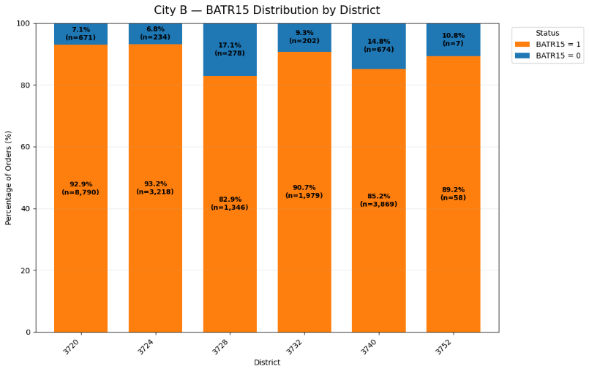
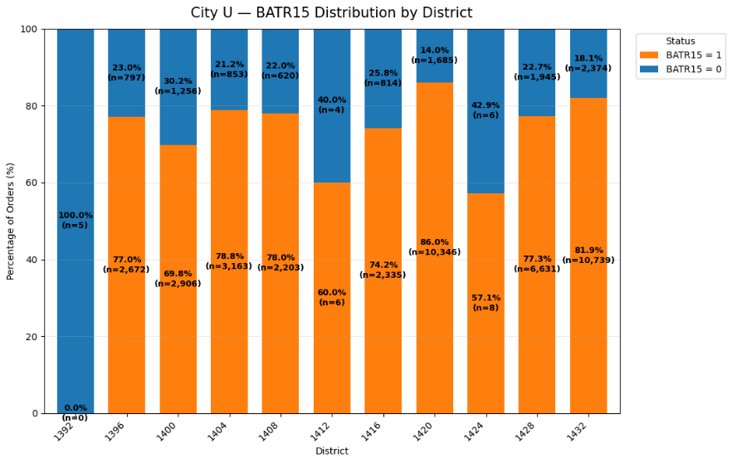
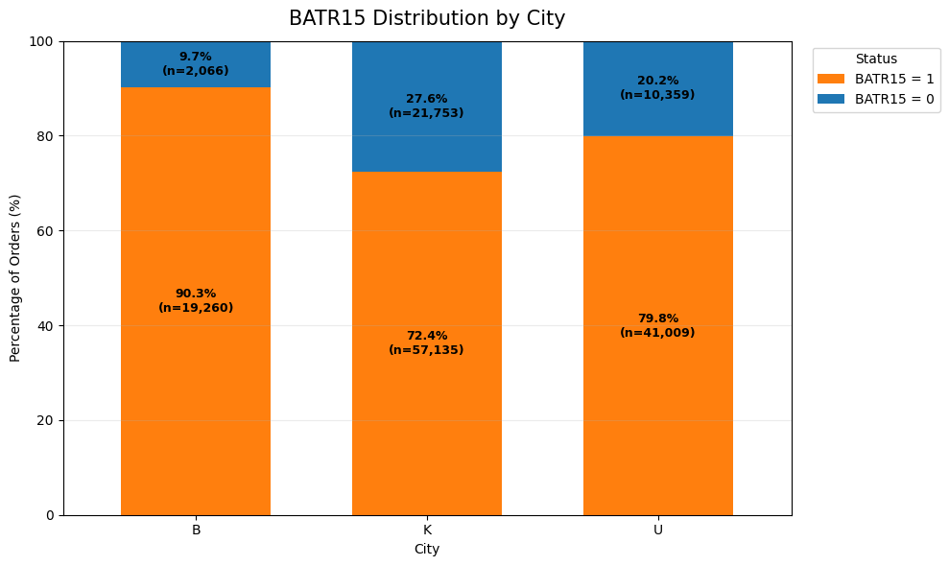

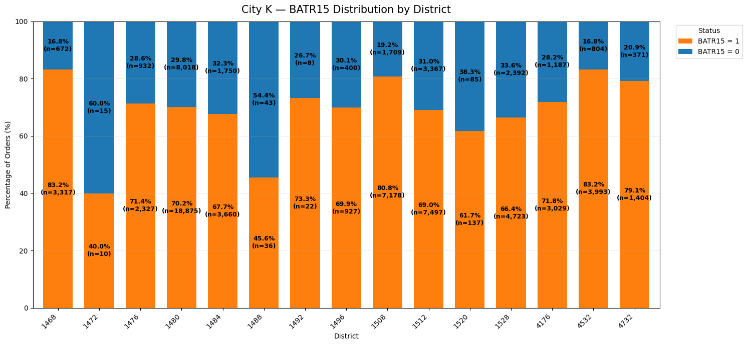

1.2 Define the 5 most important KPIs you would monitor
KPI design should be considered from several perspectives.
First, KPIs should be aligned with the organization’s objectives and the specific problem being addressed. It is therefore important to understand the business problem and identify the key parameters that may influence it.
Second, KPIs should be measurable so that their trends can be monitored before and after implementing new policies. This allows us to continuously track the state of the system.
Third, it is useful to define an alert threshold for each KPI. When a KPI crosses this threshold, attention can be directed toward the factors influencing it so that any potential issue can be identified and addressed.
When defining these thresholds, I distinguished between a Business Target and a Data-driven Alert Threshold. The 90% threshold for BATR comes directly from the company’s operational target, while for the other KPIs, since no official target was provided, alert thresholds were derived from the historical behavior of the system under healthy operating conditions.
1.2.1 – BATR Rate
This KPI represents the percentage of orders for which the biker reaches the restaurant no more than 15 minutes after start_time_slot.
$$BATR Rate = \frac{Number of Orders with BATR ≤ 15 min}{Total Valid Orders} × 100$$
It is the main Outcome KPI in this analysis and directly measures achievement of the operational BATR target.
According to the company’s stated objective, more than 90% of bikers should reach the restaurant within 15 minutes of the beginning of the Time Slot. Therefore:
Target: BATR SLA Achievement Rate ≥ 90%
Warning: BATR SLA Achievement Rate < 90%
In the dataset analyzed, the overall value of this KPI is approximately 77.45%, which is considerably below the expected target. Identifying the factors contributing to this gap is therefore the main focus of the analysis.
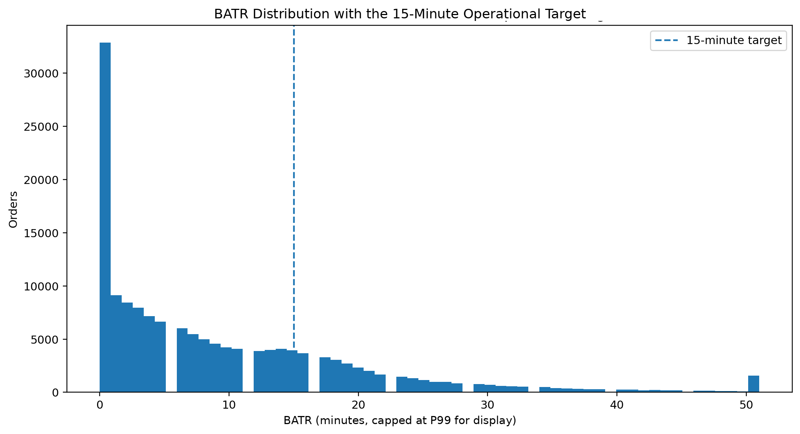
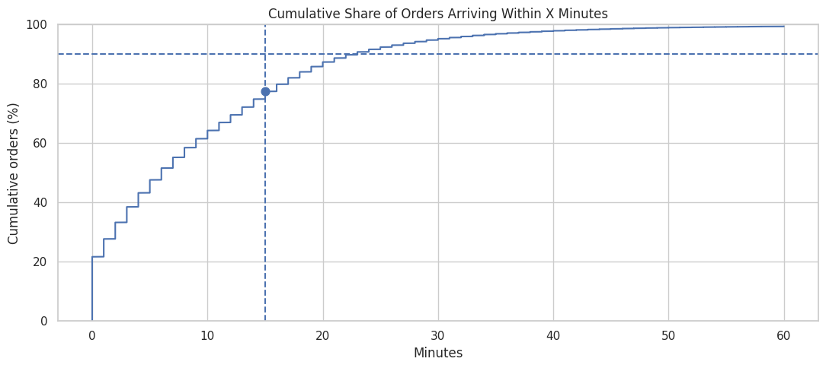
Unlike the other KPIs in this section, the threshold for this metric is derived directly from the Business Requirement rather than from a data-driven approach.
1.2.2 – Average Late Minutes after 15 (ALM15)
BATR Rate only indicates whether an order meets the 15-minute target. It does not provide information about the severity of the delay.
For example, an order with a BATR of 16 minutes and an order with a BATR of 35 minutes are both classified as Failures, even though the severity of their operational problems is not the same.
To measure this difference, Late Minutes is calculated for orders with a BATR greater than 15 minutes as follows:
$$Late Minutes = BATR - 15$$
Then:
$$ALM15 = Average Late Minutes among Orders with BATR > 15$$
This KPI therefore indicates how many minutes, on average, orders that failed to meet the target were delayed beyond the 15-minute limit.
Since the dataset contains several extremely large values that can strongly affect the average, Extreme Delays above the 99th percentile were treated separately when establishing the Baseline.
To determine the Alert Threshold, the hourly behavior of ALM15 was examined. The 75th percentile of this KPI under healthy operating conditions is approximately 11 minutes. Therefore:
Normal: ALM15 ≤ 11 min
Warning: ALM15 > 11 min
Crossing the 11-minute threshold means that the severity of delays among failed orders has entered the undesirable part of the distribution observed under healthy operating conditions. In other words, even if BATR15 has not yet changed substantially, an increase in ALM15 can serve as an Early Warning that the problem is becoming more severe.
If a more severe alert level is required, approximately 14 to 14.5 minutes, which is close to the P90 under healthy conditions, can be used as a Critical Threshold.
This KPI should be interpreted together with BATR Rate. The proportion of Late Orders may remain almost unchanged while ALM15 increases. In such a situation, the number of Failures has not changed significantly, but the existing Failures have become more severe.
1.2.3 – Acceptance Time P90
Acceptance Time is the time elapsed between the beginning of the Time Slot and the acceptance of the order by a biker:
$$Acceptance Time = accept_time - start_time_slot$$
For monitoring this stage, P90 was used instead of the Average.
Acceptance Time P90 indicates the maximum number of minutes within which 90% of orders have been accepted.
The Acceptance Time distribution has a Right Tail, with some orders having very high Acceptance Times. Under these conditions, the Mean can be strongly affected by a relatively small number of Extreme values.
The Median, on the other hand, may not be sufficiently sensitive to deterioration among slower orders. For example, Acceptance Time could increase substantially among the slowest 10% to 20% of orders while the Median remains almost unchanged.
Because the main BATR problem is also closely related to Tail Performance, P90 is a more appropriate metric for monitoring performance at the Acceptance stage. However, using the overall P90 of Acceptance Time as a threshold would not be appropriate because the overall P90 in the dataset is approximately 13 minutes, while overall BATR15 performance is already considerably below the Target. For this reason, Acceptance P90 was examined only during periods in which the system was able to maintain BATR15 at or above 90%.
Median Acceptance P90: ≈ 6 min
P75 Acceptance P90: ≈ 8.1 min
P90 Acceptance P90: ≈ 10 min
To define an Early Warning Threshold, the P75 under healthy operating conditions was selected and rounded to 8 minutes for easier reporting. Choosing 8 minutes means that if Acceptance P90 exceeds this value, performance at the Acceptance stage enters a part of the distribution observed only in approximately the worst 25% of historical healthy conditions.
From an operational perspective, this Threshold is also reasonable. If Acceptance P90 is 8 minutes, the slowest 10% of orders have at most around 7 minutes of the 15-minute BATR budget remaining for the stage after Acceptance. Any further increase in Acceptance Time therefore rapidly increases the probability of BATR15 Failure.
This relationship was also observed in the data. City-Hours with Acceptance P90 ≤ 8 min had better average BATR15 performance than periods with Acceptance P90 above 8 minutes. This relationship alone does not establish causality, but it indicates that this value is a meaningful operational Alert Threshold.
1.2.4 – Delayed Offer Rate
This KPI represents the proportion of orders for which order_offer_badge is in the delayed status.
Delayed Offer Rate is defined as follows:
$$Delayed Offer Rate = \frac{Number of Delayed Orders}{Number of Orders with Valid Offer Badge} × 100$$
The purpose of this KPI is to identify increases in the proportion of orders that enter an undesirable state during the Offer process. Analysis of the data showed that this variable has a significant relationship with BATR performance and can therefore be used as a warning indicator for deterioration in the Offer and Acceptance process.
Across the full dataset, approximately 16.3% of orders have a delayed badge. However, the difference in BATR performance between normal and delayed orders is substantial. BATR15 is approximately 89.1% for orders with a normal badge, while it drops to approximately 17.6% for delayed orders.
Moreover, although delayed orders account for only around 16% of all orders, nearly 60% of all Late Orders belong to this group. This indicates that an increase in the proportion of Delayed Offers can be an important signal of a higher risk of deterioration in BATR.
Using the average Delayed Offer Rate over the entire period would not be an appropriate method for determining the threshold for this KPI. The reason is that overall system performance during the analyzed period was below the defined BATR Target. Therefore, the overall historical average may itself represent an undesirable operating condition.
To obtain a more reliable Threshold, I first identified periods in which the system was performing well. City-Hours in which:
$$BATR15 ≥ 90\%$$
were treated as Healthy Operating Periods.
The distribution of Delayed Offer Rate during these periods showed that the Median was approximately zero, the 75th percentile was approximately 4.4%, and the 90th percentile was approximately 7.1%.
Based on these results, 5% was selected as the initial warning threshold. This value is approximately consistent with the 75th percentile under healthy conditions, meaning that crossing it indicates that Delayed Offer Rate has entered the less desirable part of the historical healthy distribution.
Therefore:
Normal: Delayed Offer Rate ≤ 5%
Warning: Delayed Offer Rate > 5%
If a more severe alert level is required, 7% can also be used as a Critical Threshold.
To evaluate the validity of the proposed Threshold, BATR performance on both sides of the 5% boundary was also compared.
In City-Hours where Delayed Offer Rate was less than or equal to 5%, Average BATR15 was approximately 90.2%. In contrast, in periods where Delayed Offer Rate exceeded 5%, Average BATR15 dropped to approximately 74%.
In addition, approximately 62.8% of periods with Delayed Offer Rate at or below 5% were able to meet the main BATR15 Target. This proportion dropped to approximately 6.2% among periods with Delayed Offer Rate above 5%.
At the City-Hour level, a strong negative relationship was also observed between Delayed Offer Rate and BATR15, with a correlation coefficient of approximately −0.86.
Taken together, these results show that the 5% threshold is not merely an arbitrary choice. It is consistent with the distribution of this KPI under healthy operating conditions and also has a clear relationship with deterioration in the main Outcome, BATR15.
1.2.5 – Post-Acceptance Arrival Time P90
Post-Acceptance Arrival Time is the time a biker spends reaching the restaurant after accepting an order:
$$Post-Acceptance Arrival Time = arrived_pickup_at - accept_time$$
P90 was also used for monitoring this stage.
Post-Acceptance Arrival Time P90 indicates the maximum number of minutes within which 90% of bikers reach the restaurant after Acceptance.
For example, an Arrival P90 of 10 minutes means that 90% of bikers reach the restaurant within 10 minutes after Acceptance.
The Arrival Time distribution has a relatively long Tail. Using the Mean can therefore make the metric sensitive to a limited number of extremely long Arrival Times, while the Median may fail to properly reflect deterioration among slower orders.
Because an increase in Arrival Time for even a relatively small proportion of orders can directly lead to BATR15 Failure, P90 is more appropriate for Operational Monitoring.
As with Acceptance, the overall Historical P90 of Arrival Time alone is not an appropriate basis for defining healthy performance because the full Historical Dataset contains many periods with poor BATR performance.
Arrival P90 was therefore analyzed during Healthy Operating Periods in which BATR15 was at least 90%.
Median Arrival P90: ≈ 8.3 min
P75 Arrival P90: ≈ 9.8 min
P90 Arrival P90: ≈ 11 min
Based on these results, the P75 under healthy conditions was rounded to 10 minutes and selected as the Early Warning Threshold.
Therefore:
Normal: Post-Acceptance Arrival Time P90 ≤ 10 min
Warning: Post-Acceptance Arrival Time P90 > 10 min
Critical: Post-Acceptance Arrival Time P90 > 11 min
Crossing the 10-minute threshold indicates that the Tail of the biker’s travel time from Acceptance to the Restaurant is moving outside the range typically observed under healthy conditions.
This Threshold also has a clear operational interpretation. If Arrival P90 exceeds 10 minutes, at least 10% of bikers spend more than 10 minutes in the post-Acceptance stage. Under these conditions, even a relatively normal Acceptance Time of 5 minutes brings the order close to the 15-minute BATR limit.
KPI | Current | Operational reference
BATR15 | 77.45 | >= 90%
ALM15 raw | 14.29 | <= 11 min
ALM15 robust P99-trimmed | 10.09 | <= 11 min
Acceptance P90 | 14.0 | <= 8 min
Delayed Offer Rate | 16.35 | <= 5%
Arrival P90 | 12.0 | <= 10 min

Metric | Healthy median | Healthy P75 | Healthy P90 | Selected warning | Unit
Acceptance P90 | 6.0 | 8.1 | 10.0 | 8 | min
Arrival P90 | 8.3 | 9.8 | 10.97 | 10 | min
Delayed Offer Rate | 0.0 | 4.42 | 7.14 | 5 | %

1.3. Identify the main dimensions you would investigate, such as: city, zone, hour, day, restaurant, biker, order characteristics
To investigate the problem, I grouped the variables available in the data into several main categories.
Geographic Dimensions
This category includes variables related to the biker’s destination, such as city, distance, and vendor. By grouping the data based on these three variables simultaneously—first by city, then district, and finally vendor—it is possible to create a practical classification of destinations.
1. Conditions differ across different areas, particularly between cities, in terms of factors such as size, population density, traffic, and other characteristics. Segmenting the data according to the vendor’s location allows for a more accurate comparison of performance across areas with relatively similar conditions. This segmentation also makes it easier to identify patterns, weaknesses, and problems at smaller geographic levels and then trace broader patterns and weaknesses through the overall flow of the data.
2. In City U, District 1424 contained nine vendors for which only 14 orders were recorded between August 2 and August 5. After that date, all of these restaurants continued operating under District 1420. Similarly, District 1412 contained five vendors for which only 10 orders were recorded between August 2 and August 4. After that date, all of these restaurants continued operating under District 1404. Apart from these cases, only seven vendors out of approximately 21,000 changed their locations. This number is negligible, so vendors can generally be treated as fixed entities.
3. According to the data, each biker provides service in only one city. Therefore, only bikers operating within a particular city can affect that city’s BATR performance, and the effect of bikers from other cities should be removed by separating the analysis by city. The same approach cannot be applied at the district level because, according to the data, bikers operated across different districts during this approximately three-month period, with the exception of Districts 4176, 4532, and 4732 in City K. In these districts, approximately 90% of bikers remain within the same district. In other districts, bikers move between multiple areas, and this rate does not exceed 20%.
Temporal Dimensions
The temporal variables include created_date, start_time_slot, accept_time, and arrived_pickup_at. The first contains the day, month, and year, while the other three also contain hour and minute information.
Days of the week and hours of the day may be among the environmental factors affecting BATR15. For example, during holidays or at certain hours, lower traffic levels may improve Arrival Time. At the same time, bikers may have fewer other commitments on these days and may therefore provide more service, which can positively affect Acceptance Time.
Lunch Peak and Dinner Peak periods, in particular, may show different behavior compared with other hours.
Order Characteristics
The variables in this category include order_fare, total_distance, batch, and order_offer_badge.
total_distance represents the distance from the restaurant to the customer. It therefore does not directly represent the distance between the biker and the restaurant, but it may affect the biker’s motivation to accept an order and may also influence order_fare.
order_fare itself may also affect biker motivation. Its effect can in fact be considered through the following variable:
$$\frac{order_fare}{total_distance}$$
The higher the value of this variable, the greater its potential effect on the biker’s willingness to accept the order. order_fare alone is not particularly informative because it may be high while total_distance is also very high. In such a case, although the biker may receive a relatively high payment, the biker may also incur substantial costs in different forms.
order_offer_badge also has a very strong relationship with BATR. However, it appears to be more of an indicator of the order’s status within the Offer process than an independent cause. Based on the explanation provided by email, I interpreted this field as follows: after a certain amount of time has passed, the delayed status is shown to the biker so that the biker becomes aware of the urgency of reaching the destination. Combined with appropriate penalty or incentive mechanisms, this may help prevent further delay.
batch was interpreted as a multi-item purchase indicator, taking the value 1 when the order is a batch and 0 otherwise.
Several potential causes of the problem can also be investigated:
1. An increase in order demand or a decrease in the supply of services across one or more nearby areas may create a shortage of service capacity for accepting and starting new orders. This would have a particularly strong effect on Acceptance Time.
2. A low level of order_fare relative to total_distance may reduce biker motivation both to accept orders and to complete deliveries, potentially affecting both Arrival Time and Acceptance Time.
3. Unfavorable natural environmental conditions, including rain, snow, cold weather, and similar factors, may reduce the number of available bikers and therefore increase Acceptance Time. At the same time, difficult travel conditions may also increase Arrival Time.
4. Unfavorable non-natural environmental conditions, including vehicle breakdowns, urban traffic, road closures, and similar disruptions, may also affect performance. In some cases, the effect may mainly be on Arrival Time, such as in the case of a vehicle breakdown, although such incidents are unlikely to have a substantial impact on overall area-level performance. In other cases, both components may be affected. Traffic, for example, may reduce bikers’ willingness to accept orders during peak traffic hours while also increasing travel time.
Other factors may also lead to a decline in BATR, but these four are provided as examples.
1.4. Write at least 5 questions you would try to answer using the data
In the next stage of the analysis, I tried to answer several main questions.
1. In which Cities and Districts is BATR15 lower, and where is the largest number of Late Orders generated?
2. In areas with a large number of Late Orders, is the problem short-term and temporary—potentially caused by a specific event during a limited period—or is it persistent and recurring, which could indicate low efficiency in parts of the system over a longer period?
3. In areas with weak operational performance, is the main problem related to Acceptance Time, Arrival Time, or are both metrics performing poorly?
4. Are there particular hours, days of the week, or months in which performance is noticeably worse? If so, is this pattern recurring?
5. To what extent do the dimensions under investigation affect BATR linearly or nonlinearly, and how does the effect of each dimension vary across different areas?
6. Which bikers have the weakest performance in each city, in which areas of that city have they performed poorly, and in which component—Acceptance Time or Arrival Time—have they performed worse?
7. Is the problem within a District driven by a few specific Vendors in that District, or is it observed across nearly all Vendors in the area?
Finally, I examined how variables such as Fare, Distance, Batch, and Offer Badge are associated with BATR and whether they can be considered Root Causes.

Task 2 – Data Analysis
In this section, the analysis was conducted to identify where and when BATR performance deteriorates, separate the roles of Acceptance Time and Arrival Time, examine conditions related to order volume, bikers, vendors, and order characteristics, and finally evaluate the variables order_offer_badge, batch, order_fare, and total_distance.
Throughout the analysis, I distinguished between three concepts:
1. Performance Problem: where BATR15 is low or the number of Late Orders is high.
2. Process Problem: the stage of the process where the greatest deterioration is observed, either Acceptance or Arrival.
3. Root Cause: the operational mechanism that creates the Process Problem.
The current data provides suitable information for the first two concepts. However, confirming some operational Root Causes, such as an actual shortage of bikers, biker location at the time of Acceptance, or the behavior of the Offer Funnel, requires additional data.
2.1. Data Preparation and Data Quality
The order_details and order_timestamp files each contained 151,803 orders, and order_id was unique in both files. The two tables were therefore merged one-to-one based on order_id.
For the main analysis period, from August through October, 151,580 orders had valid BATR values. Overall BATR15 for this period was 77.45%, which is substantially below the defined 90% Target. In total, 34,178 orders required more than 15 minutes for the biker to reach the restaurant, representing approximately 22.5% of valid orders.
One of the most important Data Quality issues involved the timestamps. For 23,803 orders, arrived_pickup_at was recorded before accept_time. These records represented approximately 15.7% of orders with valid BATR.
Following the assumption defined in Task 1, these records were not removed from the general calculations, and negative Arrival Time values were set to zero. However, analyses requiring an exact decomposition of BATR used only orders that satisfied the following chronological sequence:
$$start_time_slot ≤ accept_time ≤ arrived_pickup_at$$
This Sequential Cohort contained 127,774 orders, equivalent to approximately 84.3% of valid orders. Within this group, the following relationship holds exactly:
$$BATR = Acceptance Time + Arrival Time$$
Data-quality item | Value
Merged orders | 151803.0
Valid BATR orders Aug-Oct | 151580.0
Sequential timestamp cohort | 127774.0
Sequential cohort coverage | 84.29
arrived_pickup_at before accept_time | 23803.0
Missing start_time_slot | 221.0
Missing accept_time | 224.0
Missing biker | 16.0

For this reason, all analyses related to the relative contribution of Acceptance and Arrival, comparisons of their distributions, and Mean Decomposition were conducted using this Sequential Cohort.
Two specific cases were also observed in the geographic mapping. In City U, vendors in District 1424 were registered under this District only during the first few days of August and were then moved to District 1420. A similar pattern was observed for Districts 1412 and 1404. Because the first two Districts had very few orders and the mapping change was clear, they were not treated as independent and stable Districts in the main RCA.
Sample Size was also considered when ranking Districts. The Spearman correlation between the number of orders in a District and the width of the BATR15 Confidence Interval was approximately -0.94. Therefore, Point Estimates for very small Districts can appear randomly very high or very low because of limited Sample Size, and Prioritization should not rely only on raw BATR15.

2.2 Overall and City-Level Performance
The first major difference appeared at the City level.
City | Orders | BATR15 | Late Orders | Share of All Late Orders
B | 21,324 | 90.31% | 2,066 | 6.0%
K | 78,888 | 72.43% | 21,753 | 63.6%
U | 51,368 | 79.83% | 10,359 | 30.3%

City B, with a BATR15 of 90.31%, essentially meets the Target. City U, at 79.83%, remains substantially below the Target, while City K, with a BATR15 of 72.43%, is the weakest-performing City.
City K alone generates approximately 63.6% of all Late Orders in the Dataset. From an Operational Impact perspective, this City should therefore be the main priority for RCA and Intervention.
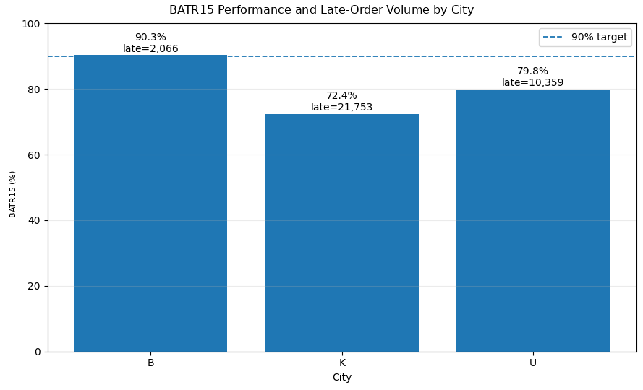
To avoid interpreting these differences only through Point Estimates, 95% Confidence Intervals were also calculated:
• City B: 89.91% - 90.70%
• City K: 72.11% - 72.74%
• City U: 79.48% - 80.18%
Statistical testing against the 90% Target also showed that Cities K and U were significantly below the Target, while there was no evidence that City B was below it. Therefore, the differences between Cities are not simply the result of Random Variation in the data.
2.3. Performance Trend over Time
Overall BATR15 for the system across the three main months was as follows:
Month | BATR15
August | 75.20%
September | 78.82%
October | 77.86%

At the City level, different patterns were observed.
City B
BATR15 increased from approximately 88.2% in August to 90.5% in September and then to 91.5% in October. City B therefore showed a relatively stable improvement trend.
City K
BATR15 was approximately 71.0% in August, 73.0% in September, and 72.9% in October. The weak performance of City K was therefore not a short-term shock and persisted throughout almost the entire period. This persistence increases the likelihood of a more structural issue rather than a short-term incident.
City U
BATR15 improved from 76.4% in August to 82.8% in September, but declined to 79.8% in October.
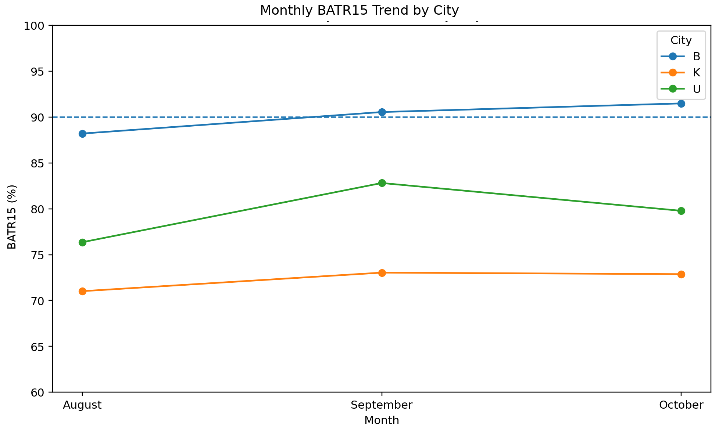
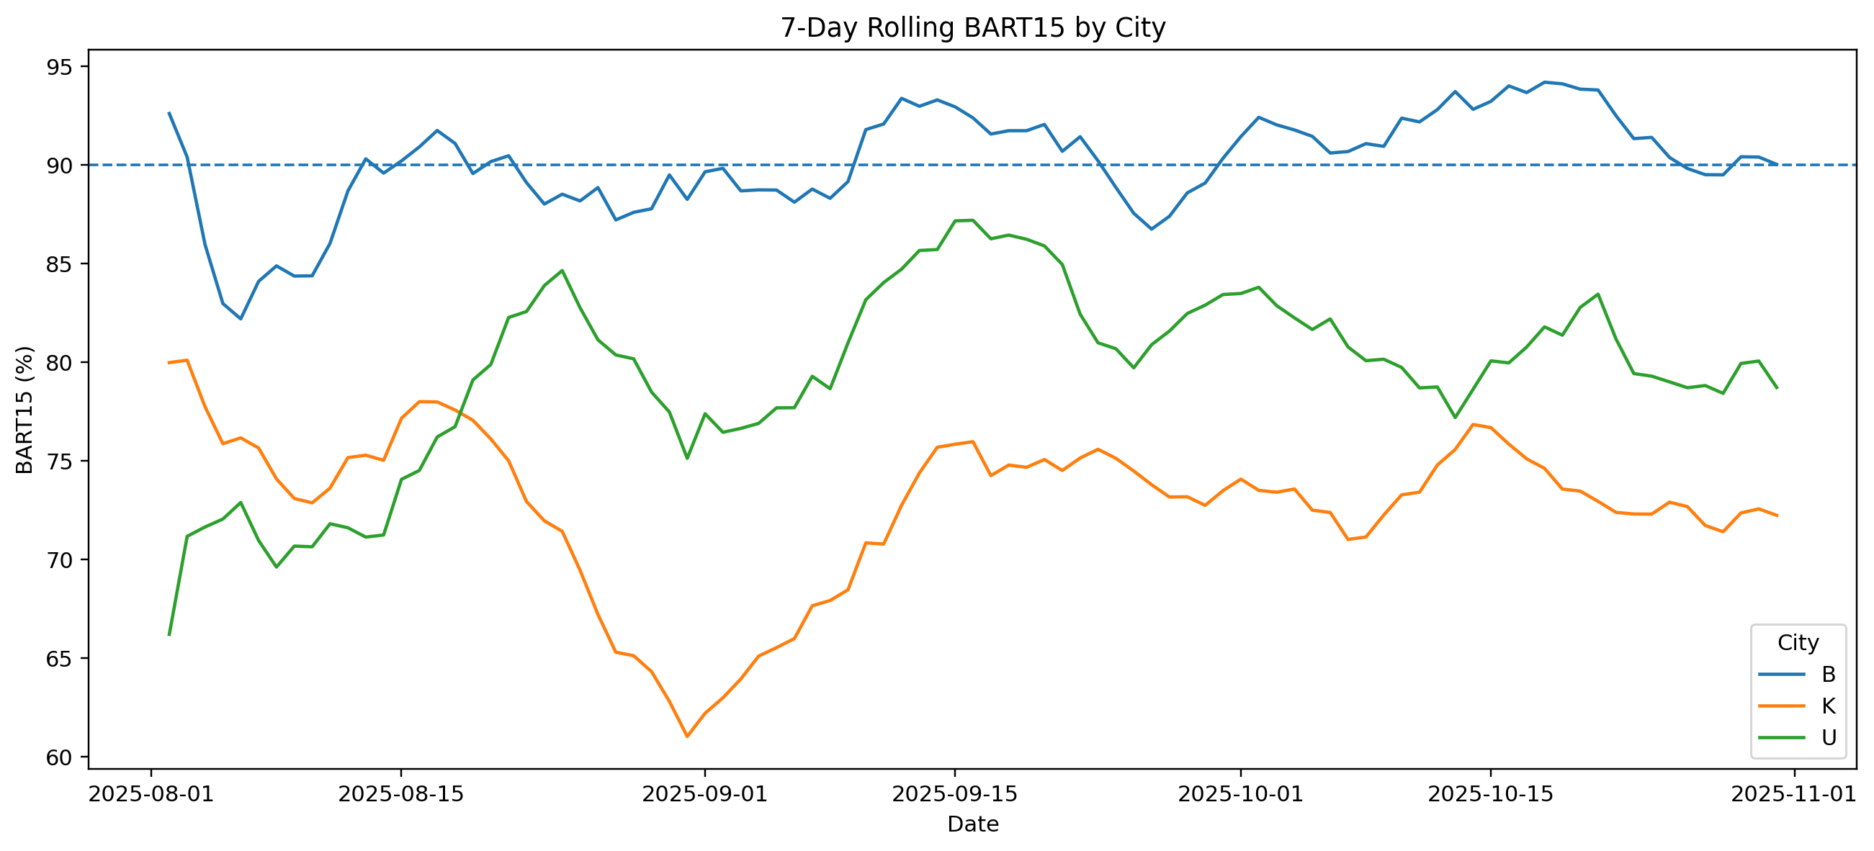
To identify which stage drove the deterioration between September and October, Mean BATR within the Sequential Cohort was decomposed into Acceptance and Arrival:
$$Δ Mean BATR = Δ Mean Acceptance + Δ Mean Arrival$$
Mean BATR in City U increased by approximately 1.74 minutes from September to October. Approximately 0.21 minutes of this increase came from Acceptance Time, while approximately 1.53 minutes came from Arrival Time.
As a result, approximately 88% of the observed deterioration in City U from September to October was related to Arrival Time. This finding shows that even within the same City, the Process Problem can change over time, which is why monitoring BATR15 alone is not sufficient for RCA.
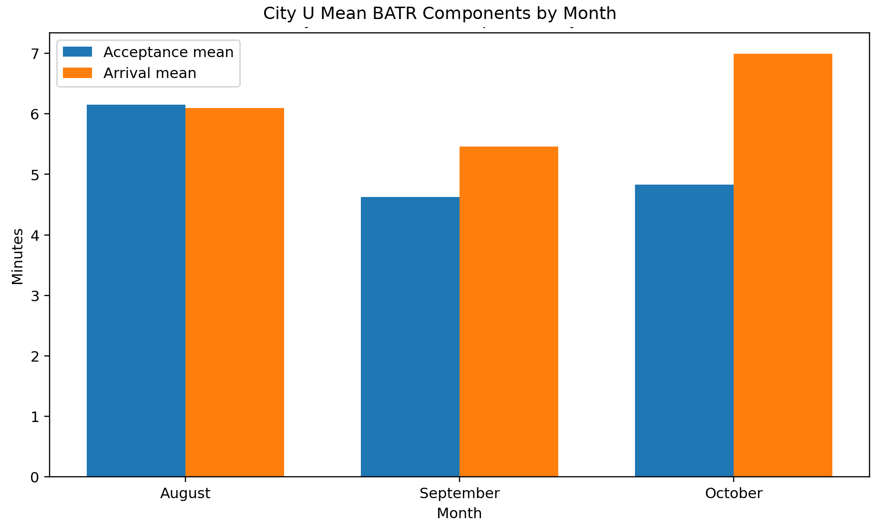
2.4. Hourly and Day-of-Week Performance
Performance was not uniform across hours of the day, and two main periods of weak performance were observed: Lunch Peak and Dinner Peak.

Hour | Orders | BATR15 | Late Orders
12 | 12,742 | 71.66% | 3,611
13 | 16,965 | 76.50% | 3,986
18 | 8,243 | 70.97% | 2,393
19 | 12,151 | 73.57% | 3,212
20 | 15,555 | 73.67% | 4,096
21 | 15,285 | 75.58% | 3,733

Hour 18 had the weakest BATR15 among hours with meaningful volume, while Hour 20 generated the largest number of Late Orders. In contrast, BATR15 was approximately 88.1% at Hour 15 and approximately 87.2% at Hour 10.
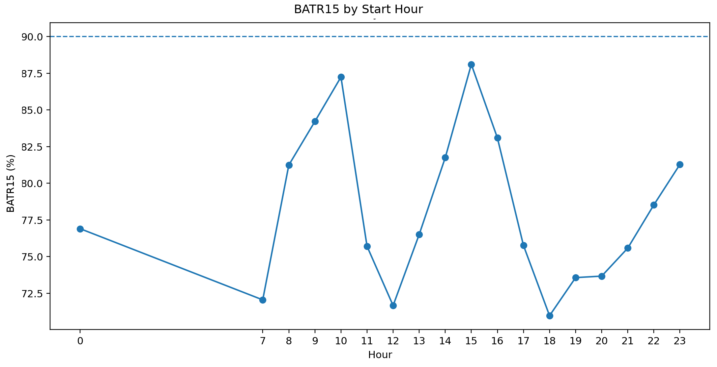
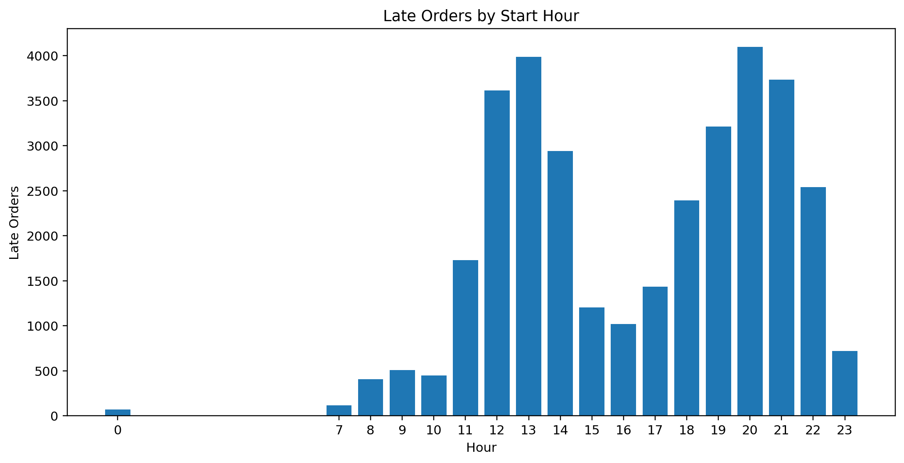
The relationship between Volume and Performance is therefore not fully linear. Some hours with substantial volume perform well, while certain Peak Hours perform noticeably worse. This indicates that Order Volume alone cannot explain BATR and should be examined together with Supply, Assignment, and travel conditions.
Day-of-Week differences were also present. BATR15 was approximately 79.8% on Sunday and 78.4% on Saturday, compared with approximately 75.9% on Thursday and 75.7% on Friday. Thursday and Friday are therefore slightly weaker, but Day-of-Week variation is substantially smaller than the differences across City, District, and Hour. Day-of-Week is useful as a Context Variable, but it is not considered the main Root Cause of the Performance Gap.
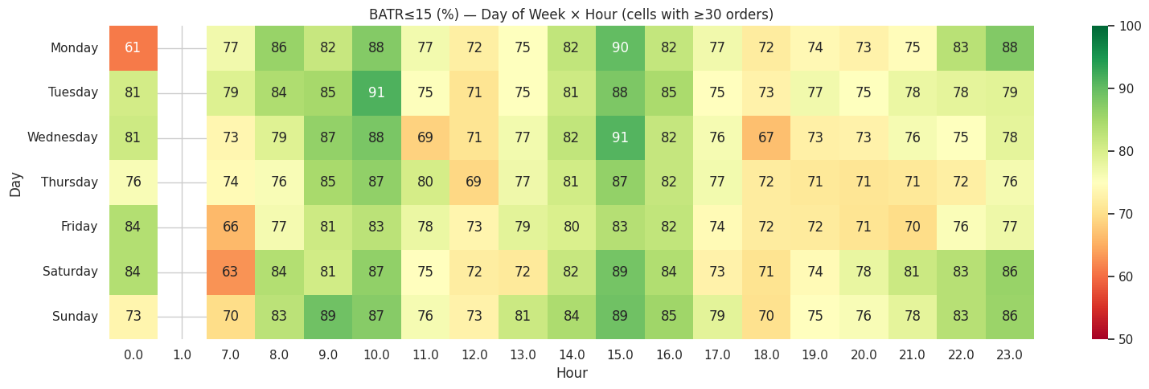
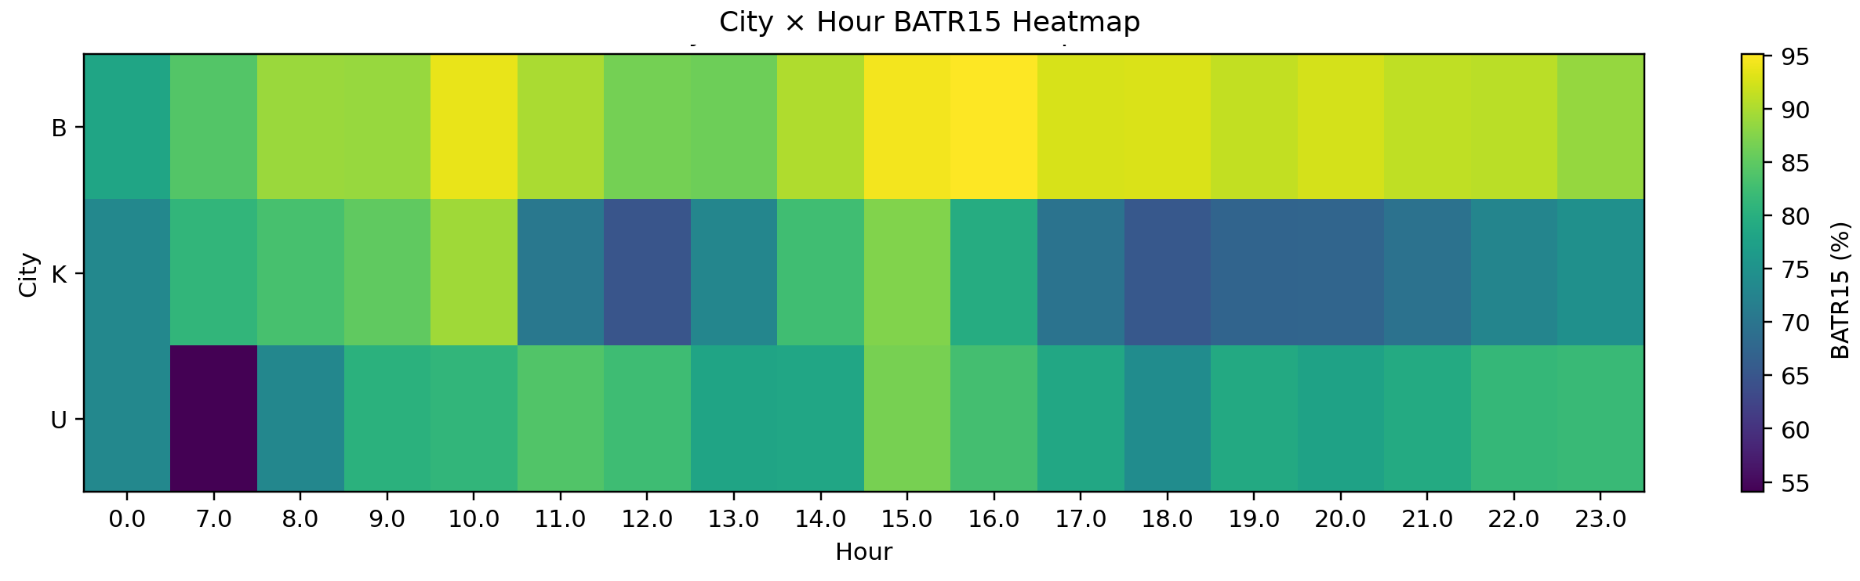
2.5. District-Level Performance and Context-Adjusted Benchmark
The number of Late Orders or raw BATR15 alone is not sufficient to identify a Local Problem. High-volume Districts naturally generate more Late Orders, and Districts with a larger share of orders during difficult hours may also have lower BATR15 even without a local operational issue.
To reduce this Composition Effect, a Leave-One-District-Out Benchmark was constructed for each District. The Context of each order was defined as:
$$City × Month × Weekday × Hour$$
For example, orders from K-1480 on Friday at Hour 20 in October were compared with the performance of other Districts in City K during the same Friday, Hour, and Month.
When calculating the Benchmark for each District, that District itself was excluded from the Comparison group so that its own performance would not influence its Benchmark.
Expected BATR15 was then calculated. Expected BATR15 represents the BATR15 a District would be expected to achieve if it experienced its actual Month, Weekday, and Hour mix but, within each Context, performed like the other Districts in the same City.
Expected BATR15 is therefore not a new Target. It is an Internal Benchmark adjusted to the actual operating conditions of that District.
$$Context Gap = Observed Context-Matched BATR15 - Expected BATR15$$
The Context Gap is interpreted as follows:
• A negative Context Gap means that the District performed worse than other Districts in the same City under comparable conditions.
• A Context Gap close to zero means that performance is largely consistent with its Context.
• A positive Context Gap means that the District performed even better than other Districts under comparable conditions.
The most important Local Underperformers were:
Area | Raw BATR15 (%) | Late Orders | Context-Matched BATR15 (%) | Expected BATR15 (%) | Context Gap (pp)
U-1400 | 69.82 | 1256 | 69.92 | 81.09 | -11.17
B-3728 | 82.88 | 278 | 83.27 | 90.84 | -7.58
K-1528 | 66.38 | 2392 | 66.27 | 73.09 | -6.81
U-1416 | 74.15 | 814 | 74.09 | 80.35 | -6.26
B-3740 | 85.16 | 674 | 85.67 | 91.81 | -6.15
K-1512 | 69.01 | 3367 | 68.43 | 73.73 | -5.3
K-1484 | 67.65 | 1750 | 67.7 | 71.8 | -4.09
K-1480 | 70.19 | 8018 | 70.11 | 73.52 | -3.4
U-1428 | 77.32 | 1945 | 77.13 | 80.28 | -3.15
U-1396 | 77.03 | 797 | 77.11 | 79.94 | -2.83
K-1496 | 69.86 | 400 | 69.91 | 72.42 | -2.51
U-1408 | 78.04 | 620 | 78.13 | 80.03 | -1.9

U-1400 is the clearest example of Local Underperformance. Given the actual Month, Weekday, and Hour mix of orders in this area, its BATR15 was expected to be approximately 81.1%, while actual performance was approximately 69.9%. The weak performance of U-1400 therefore cannot be explained only by its Time Mix.
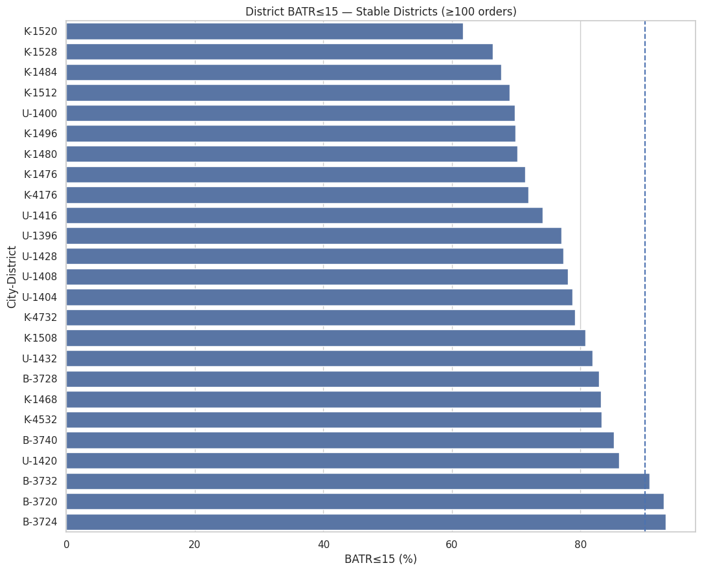
In contrast, some Districts generate many Late Orders without showing Local Underperformance. Examples include U-1432 with a Context Gap of approximately +2.53 pp, K-1508 at approximately +8.70 pp, U-1420 at approximately +8.28 pp, K-4532 at approximately +12.26 pp, and K-4732 at approximately +7.65 pp.
Despite generating 2,374 Late Orders, U-1432 performed approximately 2.5 Percentage Points better than other Districts in City U under comparable Contexts.
Prioritization should therefore consider two criteria simultaneously. Late Order Volume indicates the magnitude of Operational Impact, while the Context Gap indicates whether a District has genuine Local Underperformance.
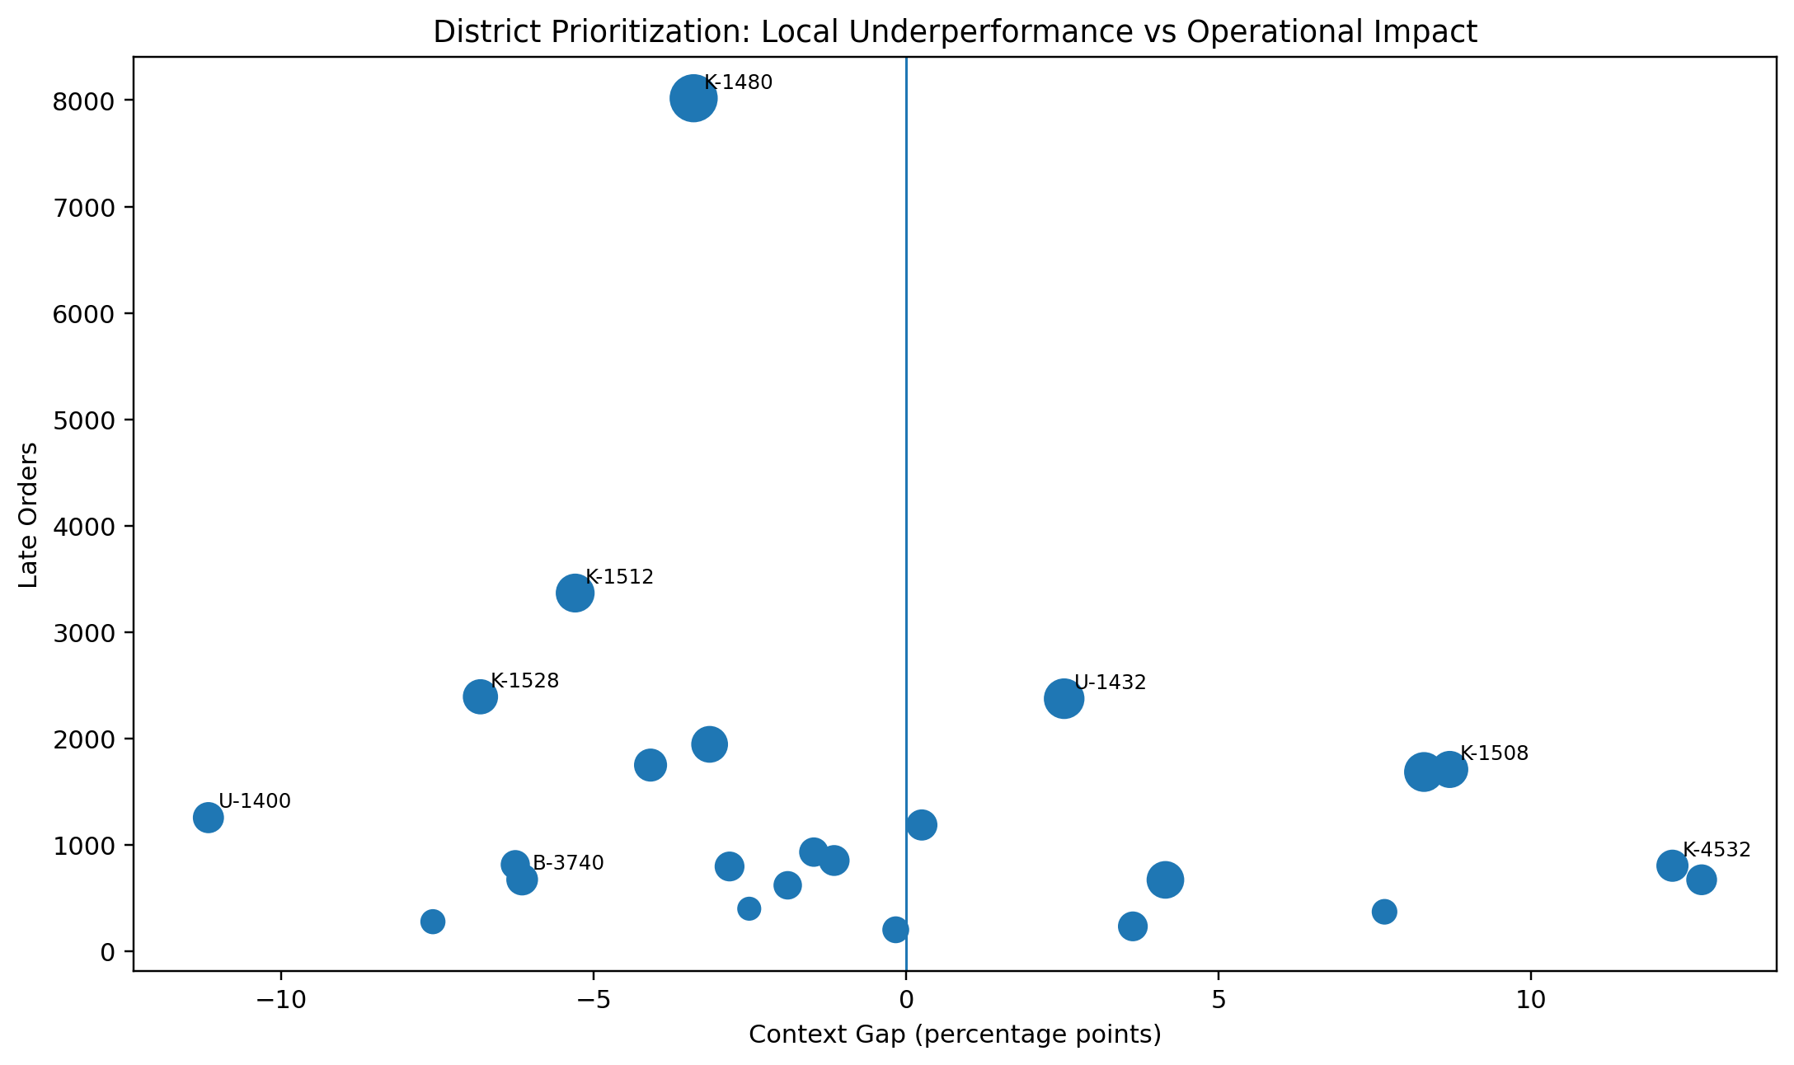
For this reason, K-1480 is particularly important. Its Context Gap is not the most severe, but it generated 8,018 Late Orders while also showing Local Underperformance.
2.6. Acceptance Time versus Arrival Time
After identifying Problematic Districts, the next step was to determine where the Delay was created within the Process. No arbitrary threshold was imposed on Acceptance or Arrival; instead, the full distributions, including Mean, Median, and P90, were examined.
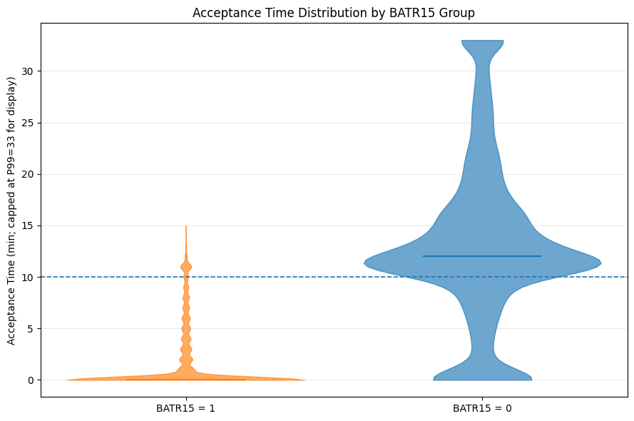
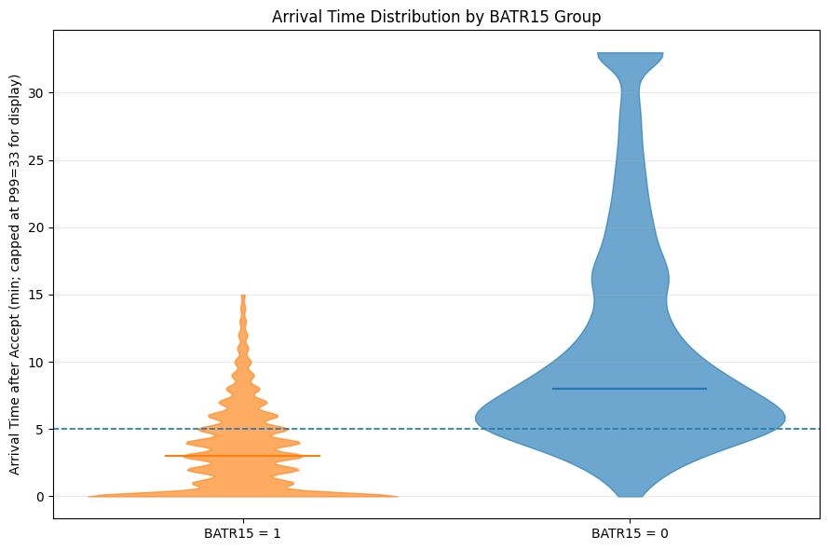
One of the most important comparisons was the difference in Acceptance and Arrival between Successful Orders and Late Orders within the same District.
For the four main Districts in City K:
District | Late Orders | Δ Median Acceptance | Δ Median Arrival
K-1480 | 8,018 | +12 min | +5 min
K-1512 | 3,367 | +13 min | +4 min
K-1528 | 2,392 | +12 min | +3 min
K-1484 | 1,750 | +11 min | +4 min
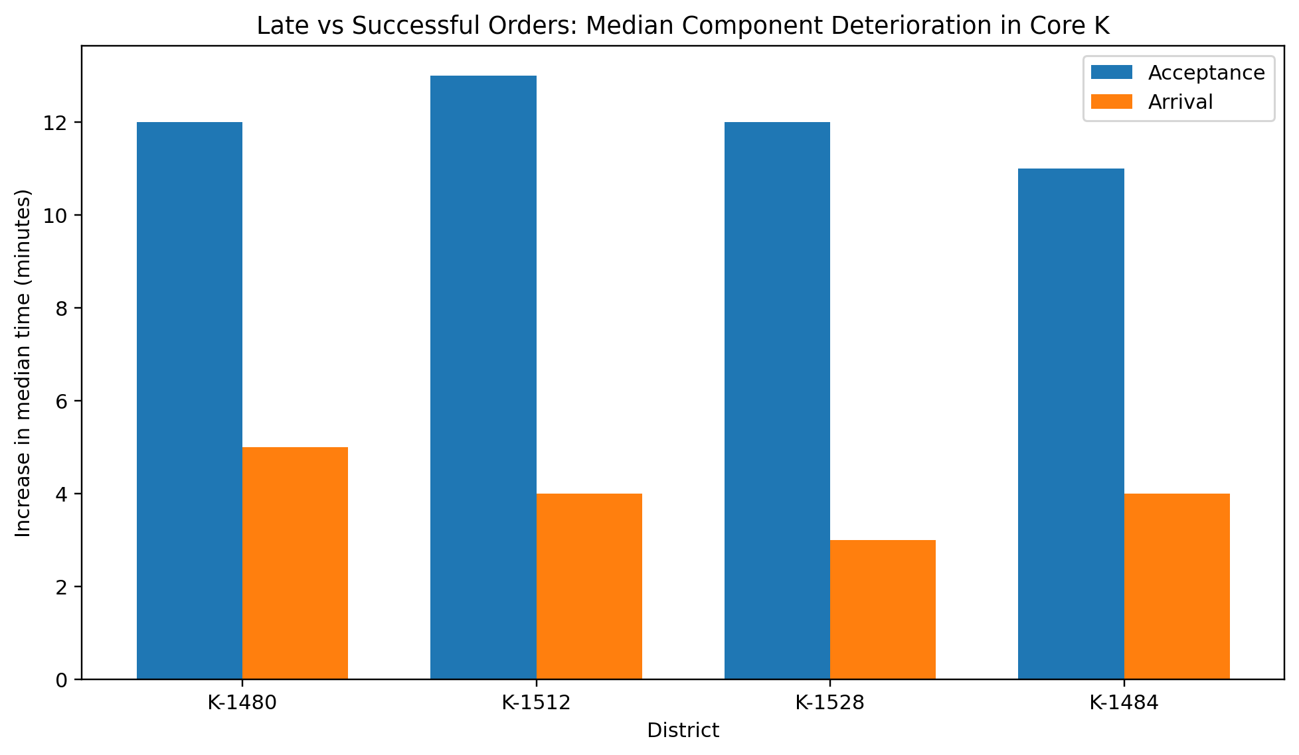

These four Districts generated a total of 15,527 Late Orders, representing approximately 71.4% of all Late Orders in City K.
In K-1512, K-1528, and K-1484, approximately 58% of the total time of Late Orders was associated with the Acceptance Stage. In K-1480, the total Acceptance and Arrival minutes were approximately balanced, but a typical Late Order was still Acceptance-heavy, and the increase in Acceptance Median was more than twice the increase in Arrival Median.
Therefore, in the Core Districts of City K, the most important Process Problem occurs before Acceptance.
Area | Orders | BATR15 (%) | Acceptance P90 | Arrival P90 | Delayed Offer Rate (%)
K-1480 | 26893 | 70.19 | 15.0 | 12.0 | 27.76
K-1512 | 10864 | 69.01 | 16.0 | 12.0 | 26.99
K-1528 | 7115 | 66.38 | 17.0 | 12.0 | 29.81
K-1508 | 8887 | 80.77 | 12.0 | 12.0 | 14.28
U-1400 | 4162 | 69.82 | 21.0 | 11.0 | 24.17
U-1420 | 12031 | 85.99 | 12.0 | 10.0 | 10.77
B-3740 | 4543 | 85.16 | 9.0 | 16.0 | 0.0
B-3720 | 9460 | 92.91 | 9.0 | 9.0 | 0.0
K-4176 | 4216 | 71.85 | 12.0 | 28.0 | 0.07
K-4532 | 4797 | 83.24 | 4.0 | 24.0 | 0.0
K-4732 | 1775 | 79.1 | 2.0 | 24.0 | 0.0

2.7. District-Hour Hotspots
A District-level average can hide severe problems during a small number of hours. Performance was therefore also examined at the District × Hour level and compared with the Baseline for the same City and Hour.
K-1480, Hour 20
• 2,846 Sequential orders
• BATR15 ≈ 56.1%
• Median Acceptance ≈ 6 minutes higher than City K at the same hour
• Arrival Median approximately equal to the City Baseline
K-1512, Hour 12
• BATR15 ≈ 49.0%
• Acceptance Median Gap ≈ +4 min
• Acceptance P90 Gap ≈ +5 min
• Arrival P90 approximately one minute better than the City Baseline
K-1528, Hour 12
• BATR15 ≈ 51.8%
• Acceptance Median and Acceptance P90 approximately +4 minutes above the Baseline
• Arrival P90 approximately 2 minutes better than the Baseline
At Hour 13 in the same District, the Acceptance Median Gap reaches approximately +7 minutes.
Area-Hour | Sequential Orders | BATR15 (%) | Acceptance Median Gap | Acceptance P90 Gap | Arrival P90 Gap
K-1480 H20 | 2846 | 56.11 | 6.0 | 1.0 | -1.0
K-1512 H12 | 1258 | 48.97 | 4.0 | 5.0 | -1.0
K-1528 H12 | 790 | 51.77 | 4.0 | 4.0 | -2.0
K-1528 H13 | 877 | 57.24 | 7.0 | 4.0 | -1.0

The same pattern therefore appears in the most important Hotspots in City K: performance deteriorates at the Acceptance Stage, while Arrival explains a much smaller share of the change.
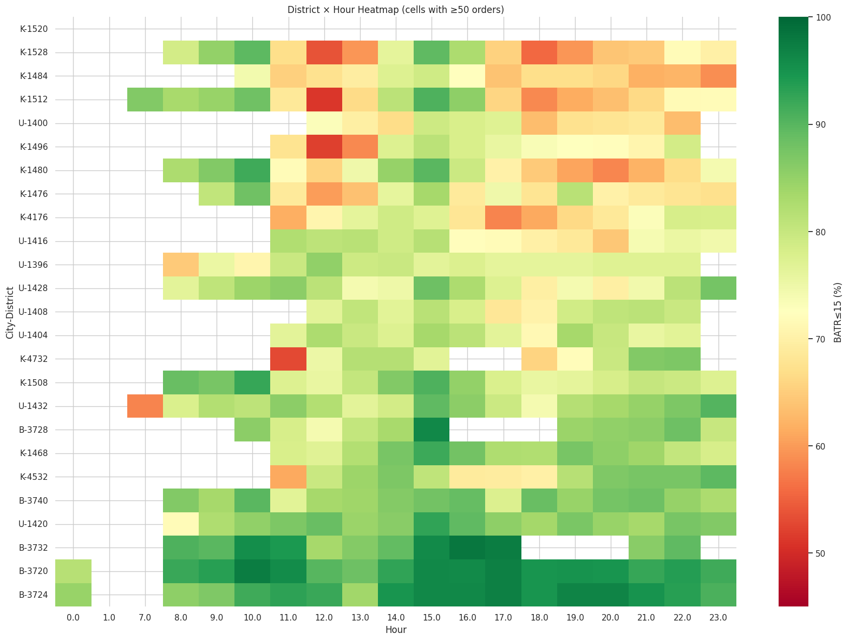
2.8. Order Load, Supply and Demand
The Dataset does not contain the true number of Active Bikers at each moment. As a result, the true Demand/ Supply Ratio and Biker Utilization cannot be measured directly from the available data.
The number of Unique Bikers who complete an order in an interval captures only bikers with an Order; Active Bikers who do not receive an Order are not visible in the data. Such a variable should therefore not be described as actual Active Supply or true Utilization.
With this limitation, Order Load was examined in 15-minute intervals at the District level. At the City level, the relationship between Order Count and Acceptance Time was generally stronger than its relationship with Arrival Time, particularly in City K.
For a more detailed comparison, High-Load and Low-Load 15-minute intervals were compared within each District. Acceptance and Arrival were adjusted relative to the City-Hour Baseline to reduce the effect of Hour.
District | Low-load BATR15 | High-load BATR15 | Change | Acceptance Change | Arrival Change
K-1480 | 79.48% | 60.06% | -19.42 pp | +4 min | +1 min
K-1512 | 77.12% | 60.75% | -16.37 pp | +3 min | ≈ 0
K-1528 | 71.42% | 61.03% | -10.39 pp | +3 min | ≈ 0
K-1484 | 67.11% | 63.81% | -3.31 pp | +1 min | ≈ 0

These results provide important evidence that in K-1480, K-1512, and K-1528, higher Local Load is accompanied by substantial deterioration in Acceptance.
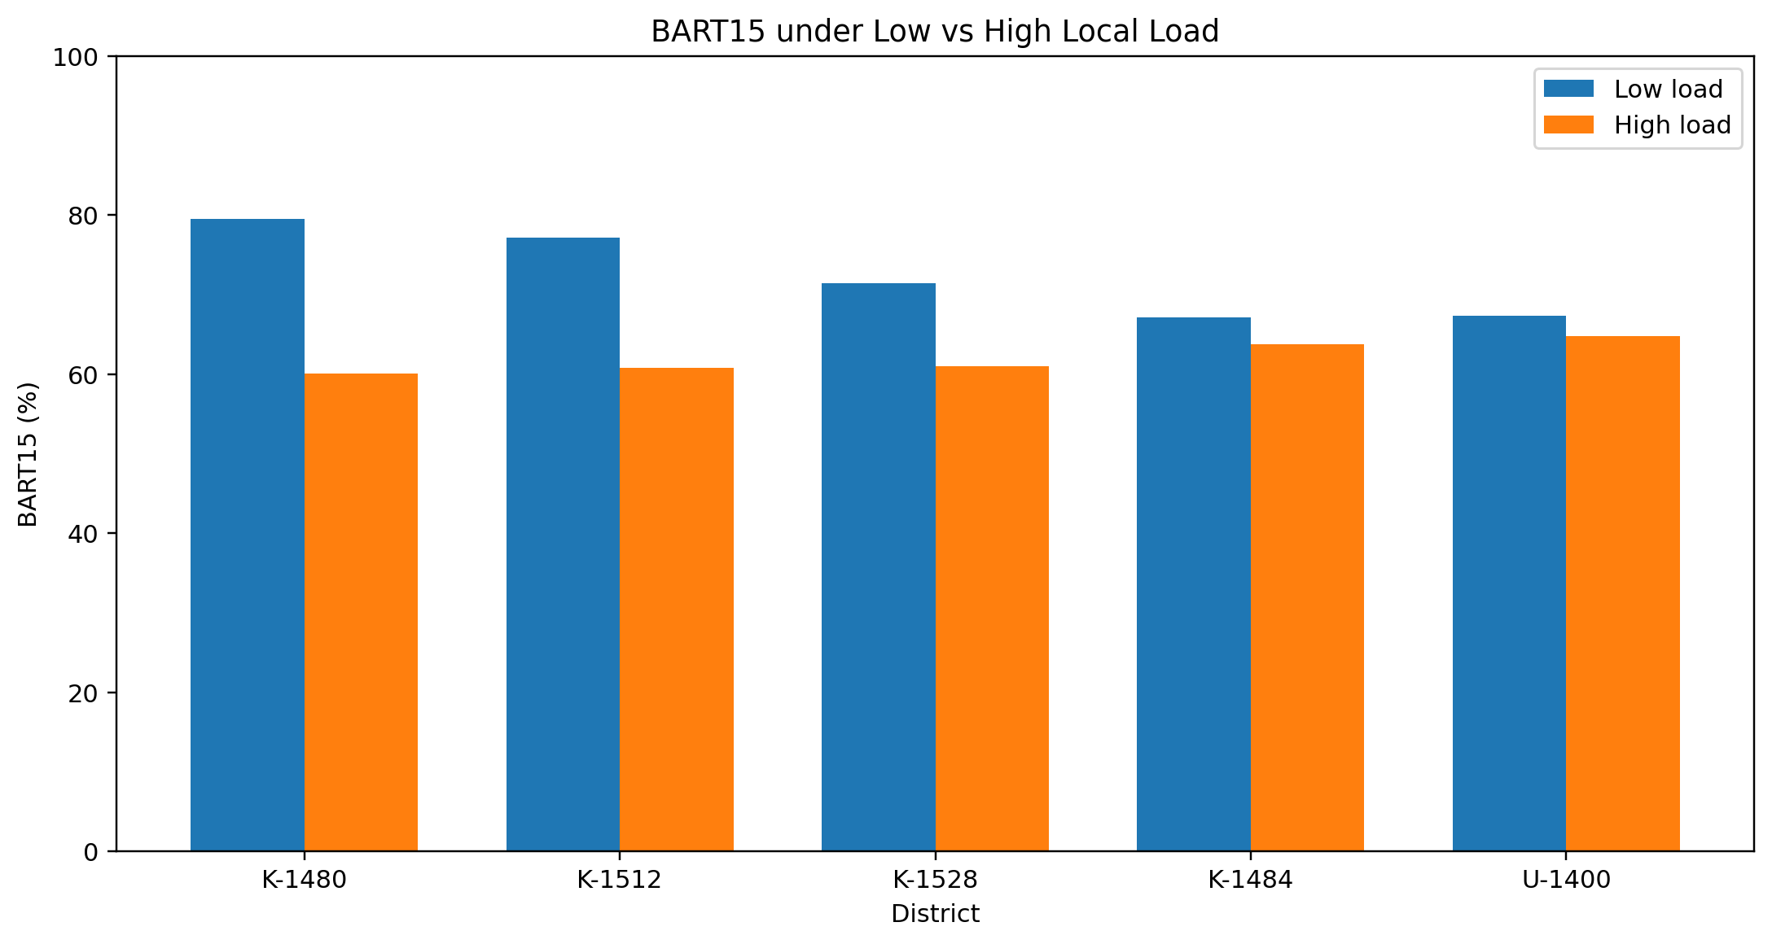
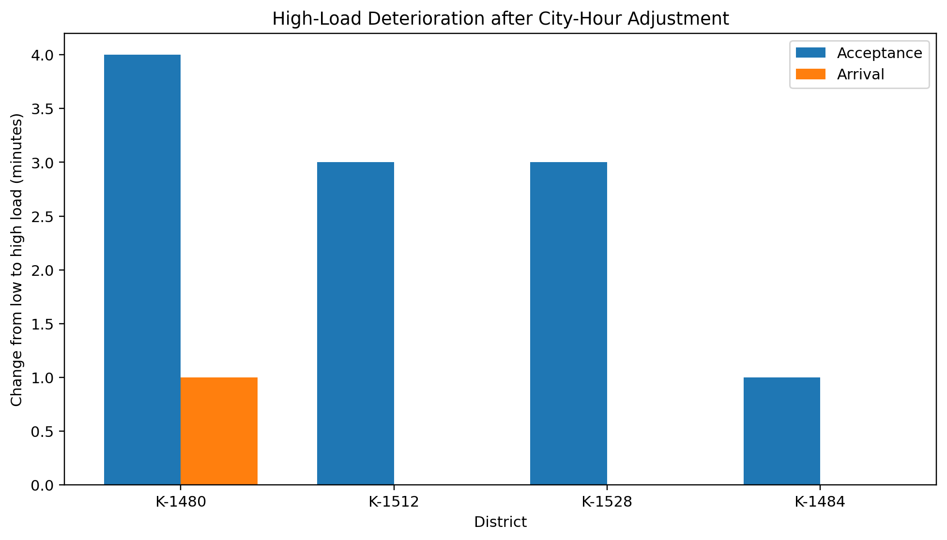
This pattern is consistent with a Supply Capacity / Assignment Problem. However, because Active Biker Data is unavailable, it cannot be concluded that an actual biker shortage is the definitive cause of the problem.
The pattern in U-1400 was different. BATR15 decreased by only approximately 2.5 Percentage Points from Low Load to High Load, while Adjusted Acceptance and Arrival remained almost unchanged. Order Load therefore does not provide a good explanation for the problem in U-1400.
2.9. Order Offer Badge
order_offer_badge was one of the strongest Operational Indicators available in the Dataset.
• Normal Badge: BATR15 ≈ 89.15%
• Delayed Badge: BATR15 ≈ 17.56%
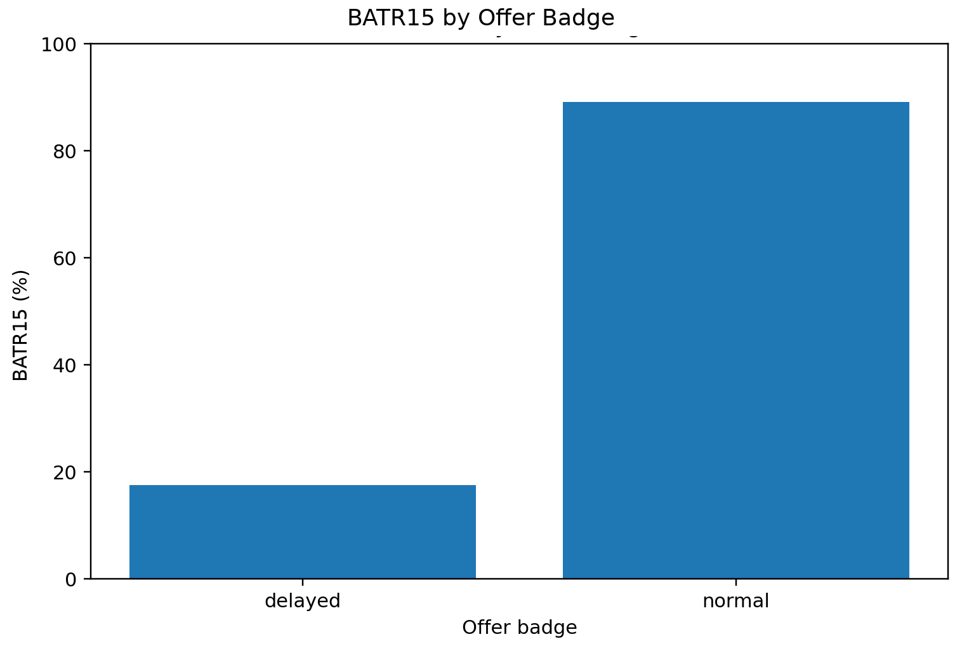
Delayed Orders represent only approximately 16.3% of all orders, but nearly 60% of all Late Orders belong to this group.
A closer analysis, however, showed that the Badge is more closely associated with the Acceptance Process than with BATR as a general indicator.
Differences Across Cities
City | Delayed Offer Rate | Normal BATR15 | Delayed BATR15
B | 0.0% | 90.31% | —
K | 21.59% | 87.09% | 19.16%
U | 15.06% | 91.50% | 14.03%

No Delayed Badge was recorded in City B during the entire period. Delayed Offer Rate should therefore not be compared across all Cities without accounting for City, and the Badge Assignment Process is likely not identical across Cities.
In the Core K Districts with Acceptance Problems, Delayed Offer Rate is much higher:
• K-1480: 27.76%
• K-1484: 27.13%
• K-1512: 26.90%
• K-1528: 29.81%
• U-1400: 24.17%
In contrast, three Arrival-driven Districts in City K have almost no Delayed Badge:
• K-4176: ≈ 0.07%
• K-4532: 0%
• K-4732: 0%
This difference is important. Delayed Offer Rate mainly reflects an undesirable state in the Offer/Acceptance Process and does not capture Arrival Problems to the same extent.
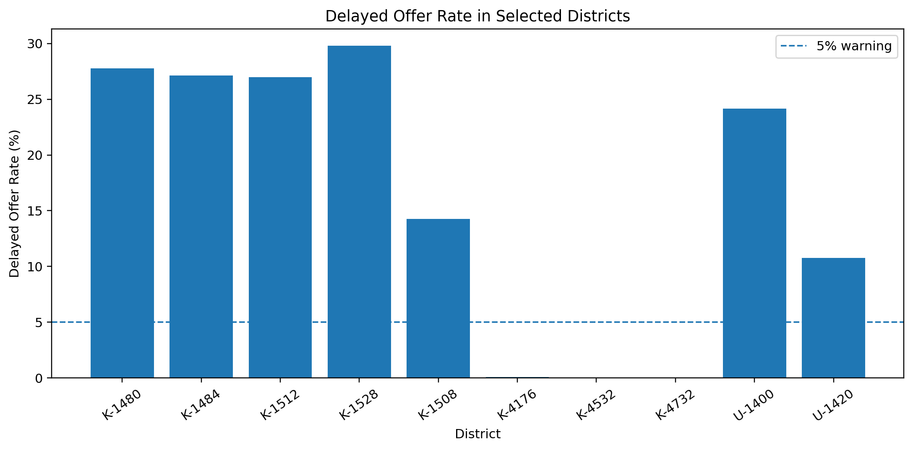
At the City-Hour level in Cities K and U, Delayed Offer Rate also had a much stronger relationship with Acceptance P90 than with Arrival P90:
• City K: Correlation with Acceptance P90 ≈ 0.81; with Arrival P90 ≈ 0.24
• City U: Correlation with Acceptance P90 ≈ 0.88; with Arrival P90 ≈ 0.28
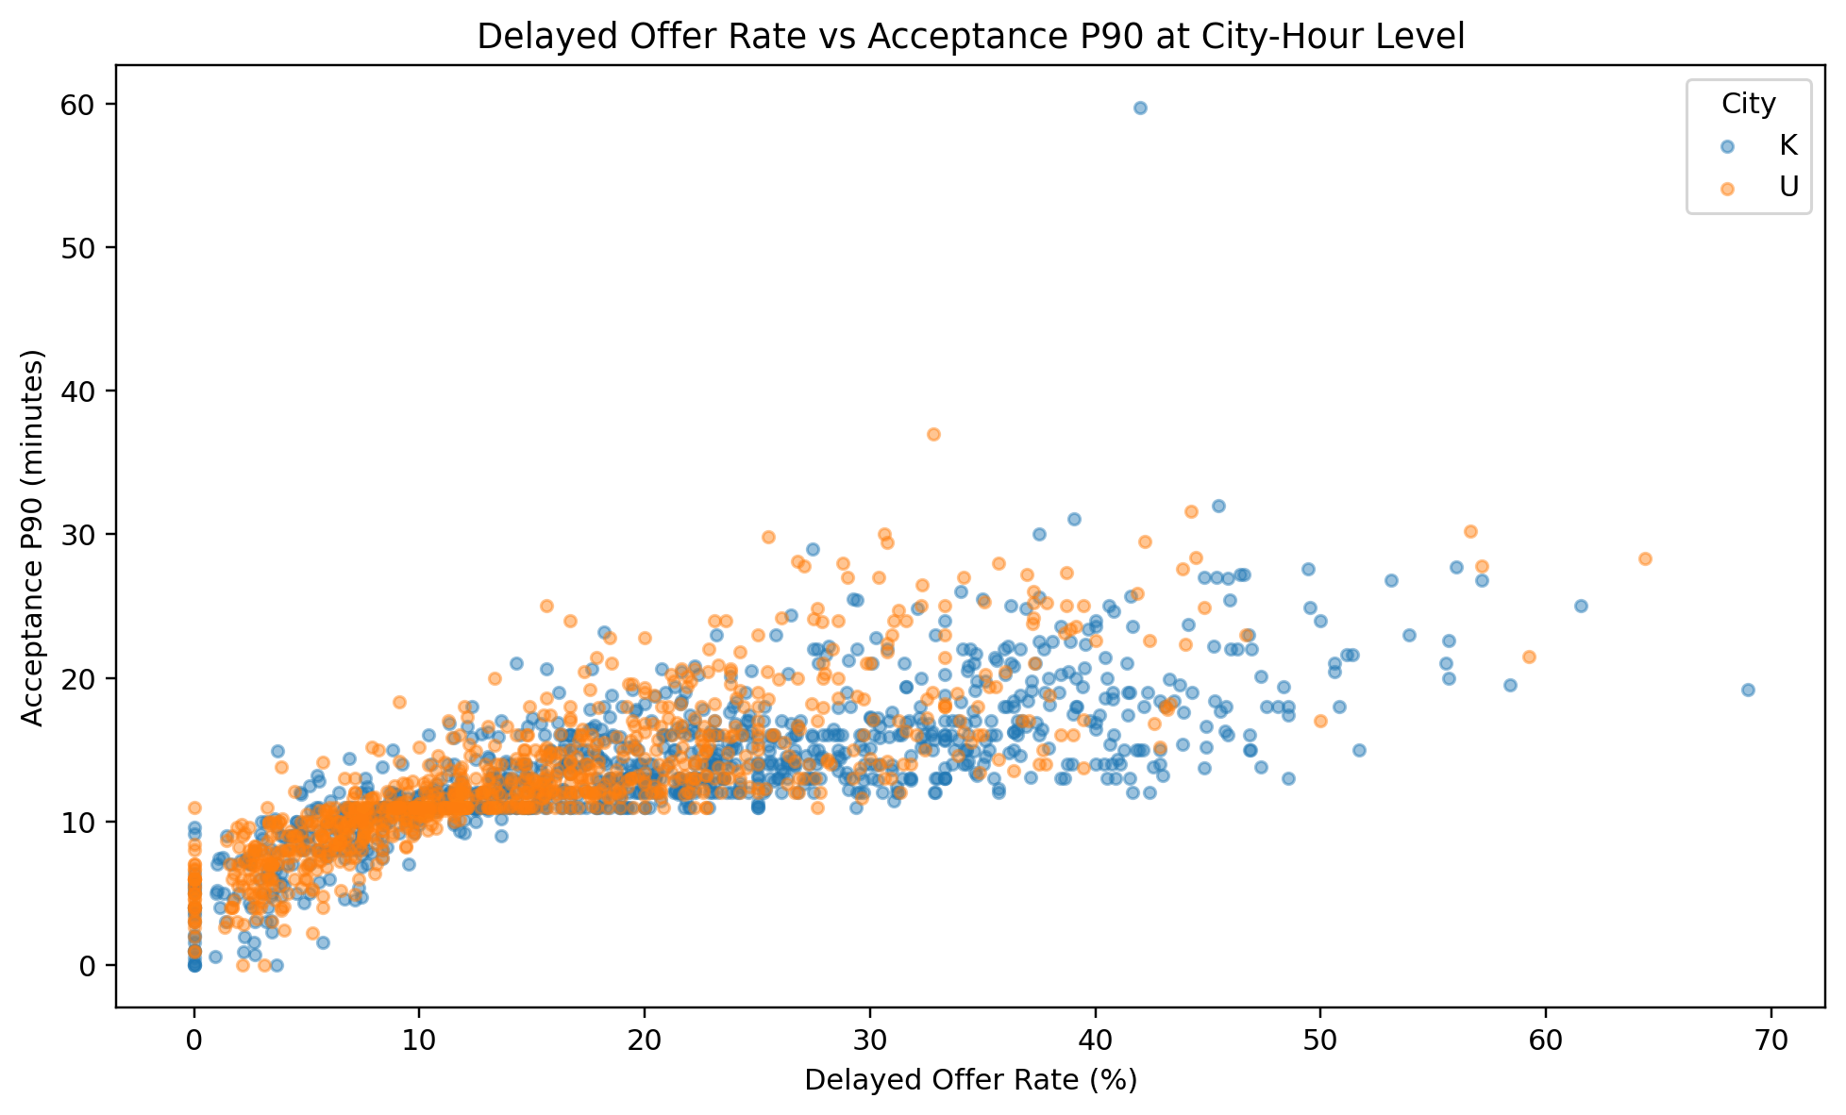
Badge Assignment Pattern
The probability of receiving a Delayed Badge was also examined against Acceptance Time. Up to approximately 8 minutes, almost no Delayed Badge is observed. At minute 10, the Delayed Rate is approximately 10%, but around minute 11 a very large jump occurs and more than 85% of orders have a Delayed Badge.
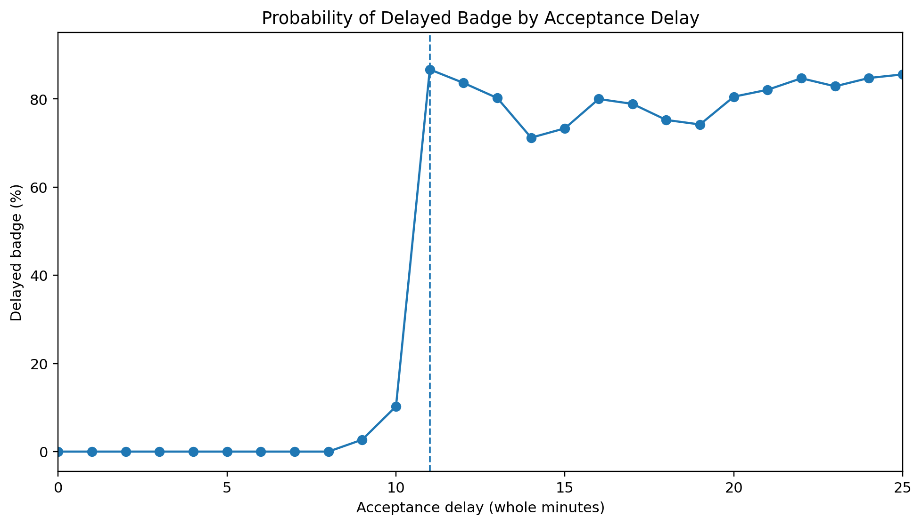
A Local Regression around this point also showed a jump of approximately 69 to 79 Percentage Points, depending on the Bandwidth.
This pattern suggests that the Badge is likely generated based on a rule related to Waiting Time. However, using this threshold to estimate a Causal Badge Effect on BATR would not be valid because Acceptance Time is itself directly part of BATR.
The Delayed Badge is therefore a very useful Process Indicator, but it should not be treated as an independent Root Cause.
2.10. Fare, Distance and Fare per Distance
The variables order_fare, total_distance, and the Fare-to-Distance ratio were examined separately. Fare and Distance showed a relatively strong relationship:
Pearson Correlation: ≈ 0.75
Spearman Correlation: ≈ 0.78
A substantial amount of information in these two variables is therefore shared.
Total Distance
BATR15 was approximately 86.1% in the shortest Distance Decile and approximately 70.8% in the longest Distance Decile. At the same time, Arrival P90 increased from approximately 9 minutes in the shortest Distance Decile to approximately 15 minutes in the longest Decile.
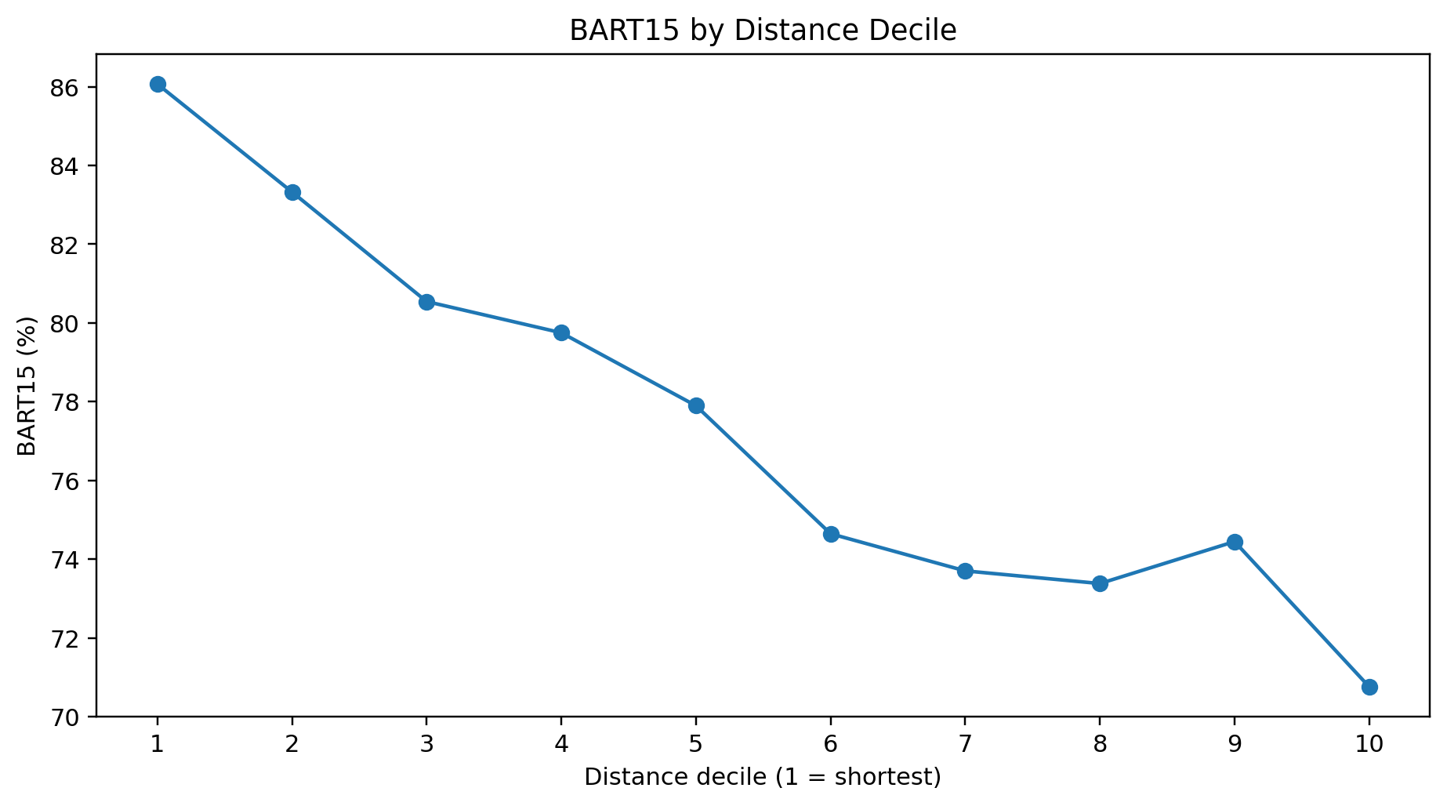
However, total_distance represents the distance from the Restaurant to the Customer, while BATR ends at the Restaurant. This Distance therefore does not directly measure the distance traveled by the Biker before reaching the Restaurant.
Its correlation with Acceptance and Arrival was also relatively weak:
City | Distance vs Acceptance | Distance vs Arrival
B | 0.03 | 0.05
K | 0.02 | 0.10
U | 0.07 | 0.10

Customer Distance alone is therefore not a strong driver of BATR and is more likely associated with Performance through Composition, Geography, or order Attractiveness.
Order Fare
The raw relationship between Fare and BATR was much stronger. BATR15 decreased from approximately 96.6% in the lowest Fare Decile to approximately 51.1% in the highest Fare Decile.
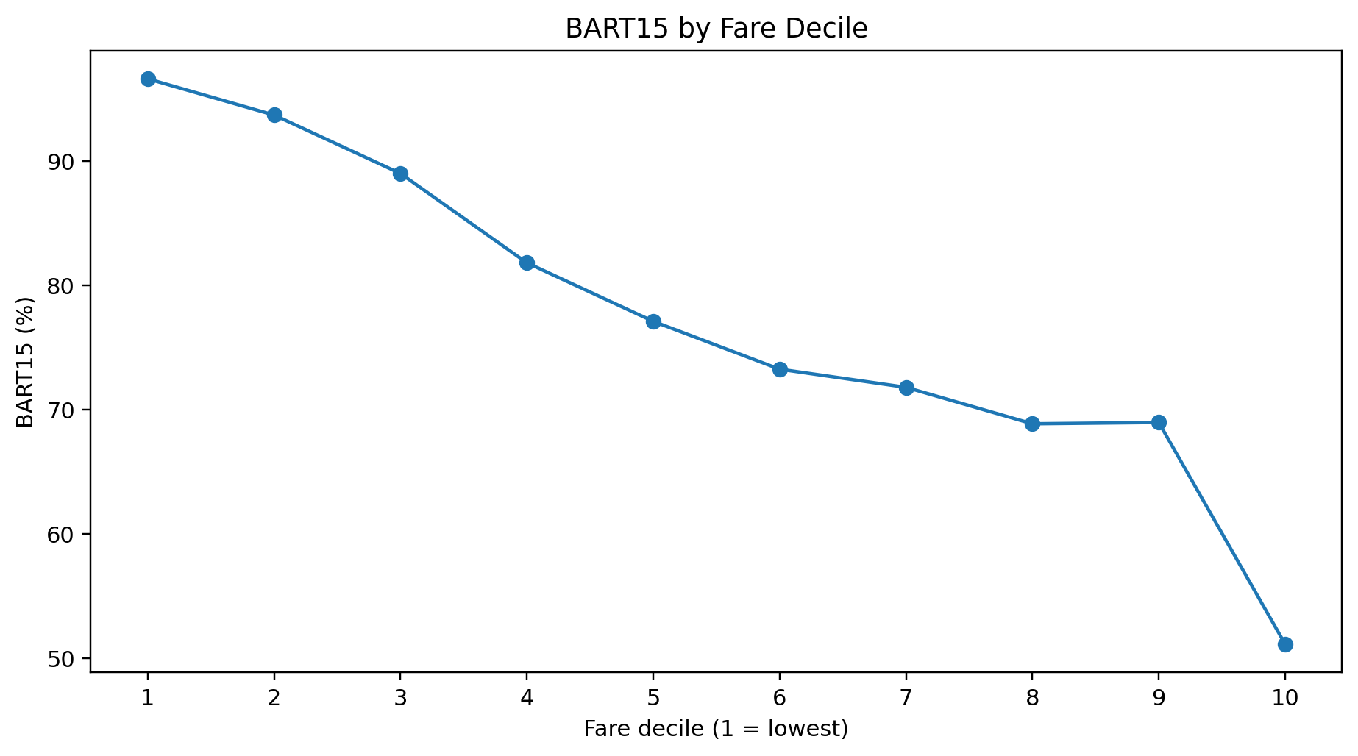
At the same time, in the lowest Fare Decile, Acceptance P90 was approximately 2 minutes and Arrival P90 approximately 7 minutes. In the highest Fare Decile, Acceptance P90 was approximately 17 minutes and Arrival P90 approximately 18 minutes.
Despite this pattern, it would be incorrect to conclude that higher Fare causes worse BATR.
Delayed Orders have, on average, higher Fare, higher Distance, and a different City Composition. For example, Mean Fare is approximately 0.96 million units for Normal Orders and approximately 1.50 million units for Delayed Orders.
After conditioning on Badge, the relationship between Fare and BATR15 becomes substantially weaker; among Delayed Orders, almost no clear relationship remains between Fare and BATR15.
In the Regression, the association with Fare also declined sharply after adding Badge, Batch, District, and Time Controls. Fare is therefore an important Predictive Factor, but the current evidence does not justify treating it as a Root Cause.
Fare per Distance
The initial Hypothesis was that low Fare relative to Distance might reduce biker motivation. The data did not support this Hypothesis in a simple form.
In the three lowest Fare-per-Distance Deciles, BATR15 was approximately 88% to 90%, while in the middle and higher Deciles it was mainly between 70% and 79%. The observed pattern is therefore not consistent with the claim that lower Fare per Distance necessarily leads to worse BATR.
This result is reasonable because the denominator of this Ratio is Restaurant-to-Customer Distance and does not necessarily represent the Biker’s actual effort before Acceptance or the distance from the Biker to the Restaurant.
A general increase in Fare therefore cannot be recommended based on the current data.
2.11. Batch
The Raw Comparison initially produces a relatively misleading result:
• Batch = 0: BATR15 ≈ 77.17%
• Batch = 1: BATR15 ≈ 79.48%
At first glance, this could suggest that Batch Orders perform better. However, the two groups differ substantially in their Order Characteristics.
On average, Batch Orders:
• have shorter Distance: approximately 1.77 km versus 3.27 km
• have lower Fare: approximately 0.79 versus 1.09 million units
• have a much lower Delayed Offer Rate: 4.7% versus 17.9%
• have a larger share of orders located in City U
The Raw Comparison is therefore affected by Selection Bias.
After comparing Batch and Non-Batch orders within the same Badge group, the direction of the relationship changes completely:
Offer Badge | Batch = 0 | Batch = 1
Normal | 90.09% | 83.28%
Delayed | 18.10% | 2.55%

Within both Badge Groups, Batch Orders have weaker BATR15 performance.
To compare more similar orders, Matching was performed based on:
$$City + Hour + Badge + Distance Quintile + Fare Quintile$$
There were 883 comparable groups in which both Batch and Non-Batch orders were observed. The Weighted BATR15 difference was:
$$Batch = 1 - Batch = 0 ≈ -8.21 Percentage Points$$
Scope | Matched strata | Batch minus Non-Batch BATR15 (pp)
All cities | 883 | -8.21
City B | 125 | -3.11
City K | 379 | -9.17
City U | 379 | -7.86

The same pattern was observed across Cities:
• City B: ≈ -3.1 pp
• City K: ≈ -9.2 pp
• City U: ≈ -7.9 pp
In a simple Linear Probability Model, Batch initially appeared to be associated with approximately +2.3 Percentage Points in BATR15. After adding Badge, Fare, Distance, District, and Time Controls, however, the Batch coefficient changed to approximately -9.35 Percentage Points.
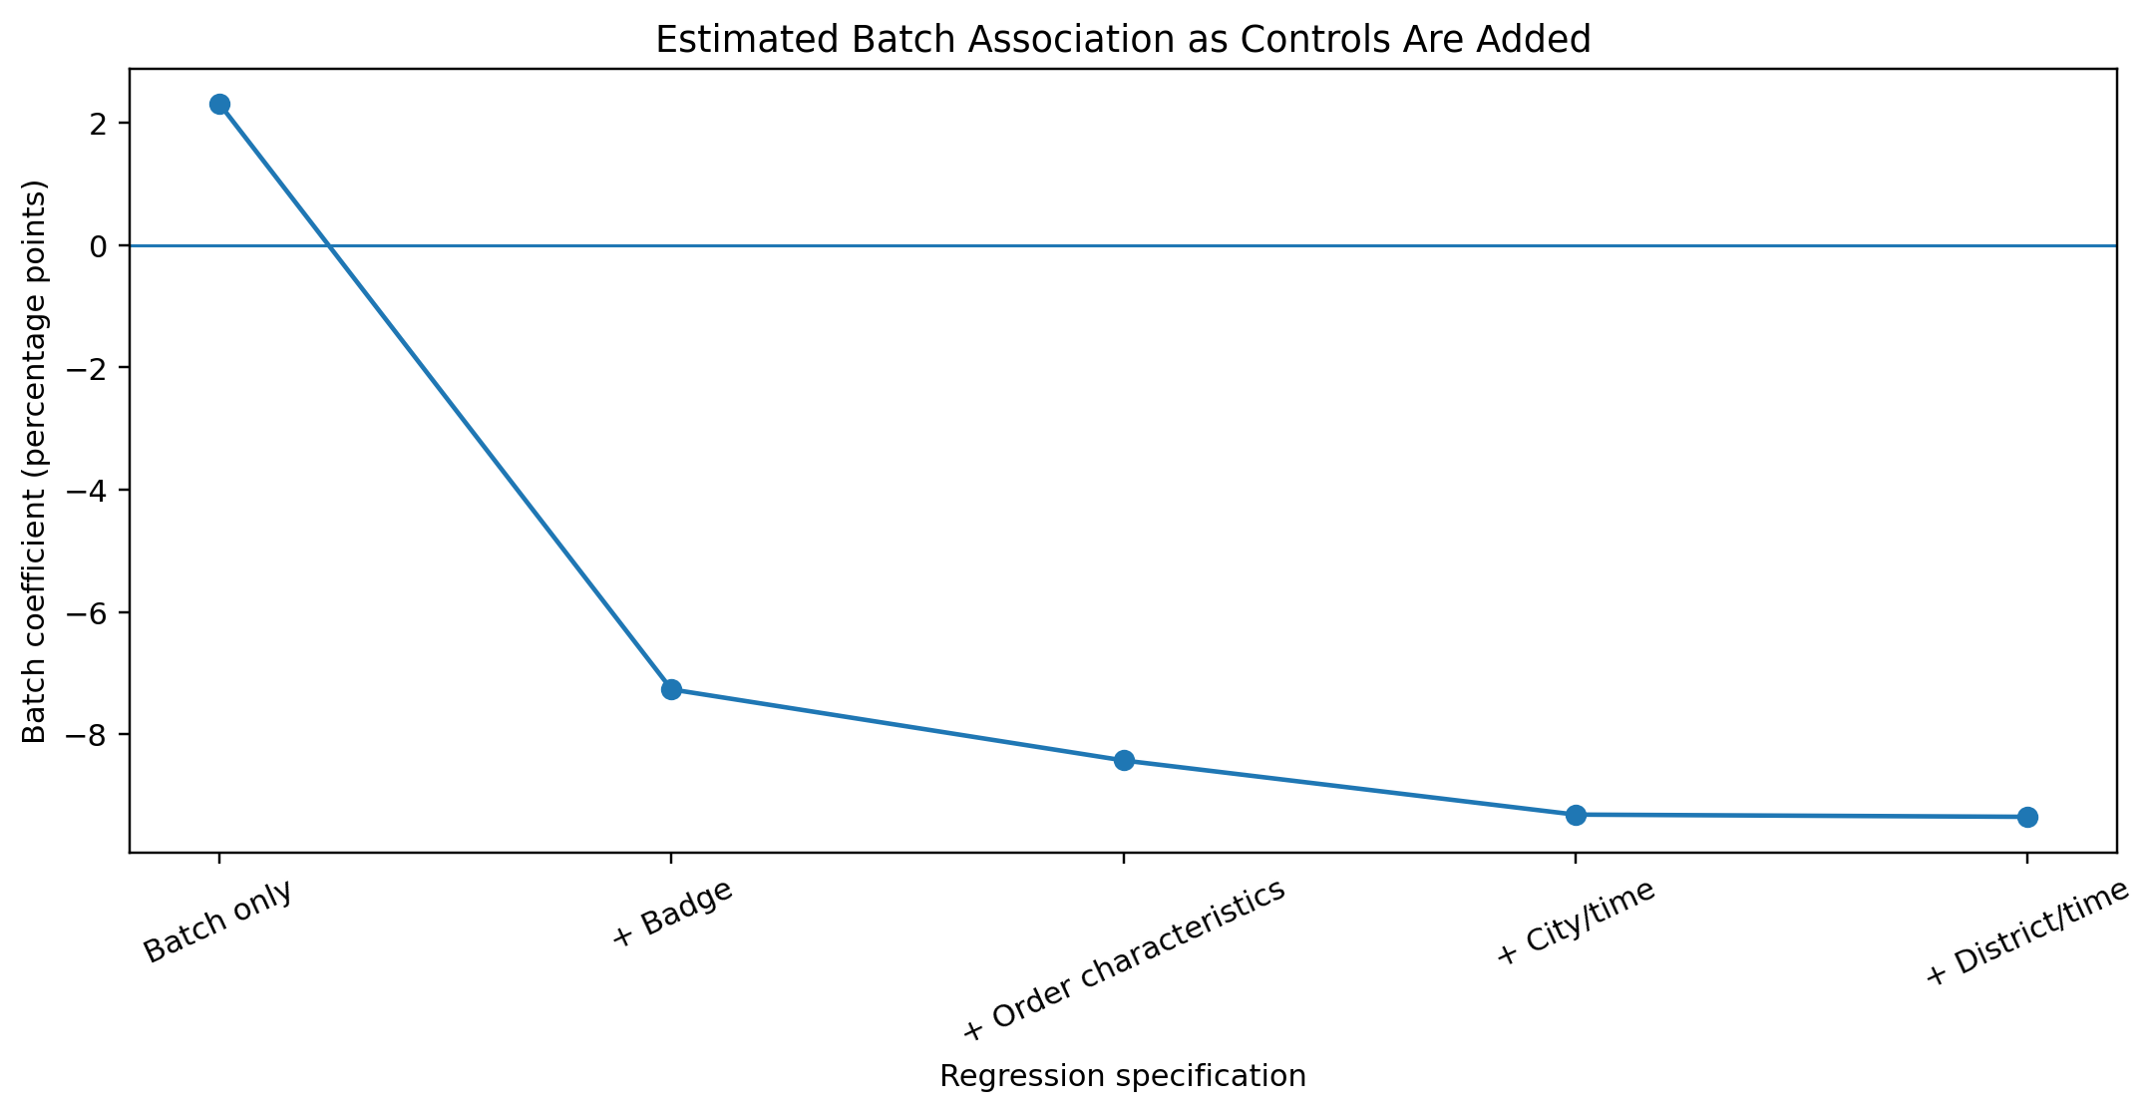
In the final model with Standard Errors Clustered by Biker, the result was almost identical:
$$Batch coefficient ≈ -9.36 pp$$
This sign reversal is a clear example of Selection Bias and shows that the Raw Comparison for Batch is not reliable.
However, this result still does not establish a Causal Batch Effect because Batch was not Randomly Assigned and unobserved factors may influence its Assignment.
Batch should therefore be treated as a Conditional Risk Factor, and any Policy change should be evaluated through a Controlled Experiment or a comparable Rollout.
2.12. Biker-Level Analysis
The Biker Dimension was also examined separately. Approximately 4,298 bikers were observed in the full dataset, and no biker operated in more than one City. The Biker analysis was therefore conducted at the City level.
An important point when interpreting Biker Performance is that Acceptance Time cannot be directly attributed to the final biker. An order may have been offered several times or remained in the Queue for a long time before being accepted by the final biker.
Arrival Time is therefore a more defensible metric for evaluating Individual Biker Performance. To reduce the effect of Location and Hour, each order’s Arrival Time was compared with the Arrival Median for the same District × Hour.
Among bikers with at least 30 Sequential orders, the group at or above the 90th percentile of Adjusted Arrival Time was examined.
City | Share of Orders | Share of Late Orders | BATR15 of High-Arrival Group | City Sequential BATR15
B | 10.9% | 16.9% | 78.4% | 86.0%
K | 11.1% | 15.5% | 56.2% | 68.7%
U | 10.0% | 16.4% | 61.1% | 76.2%

A relatively small group of bikers therefore accounts for a larger share of Late Orders than its share of Order Volume.
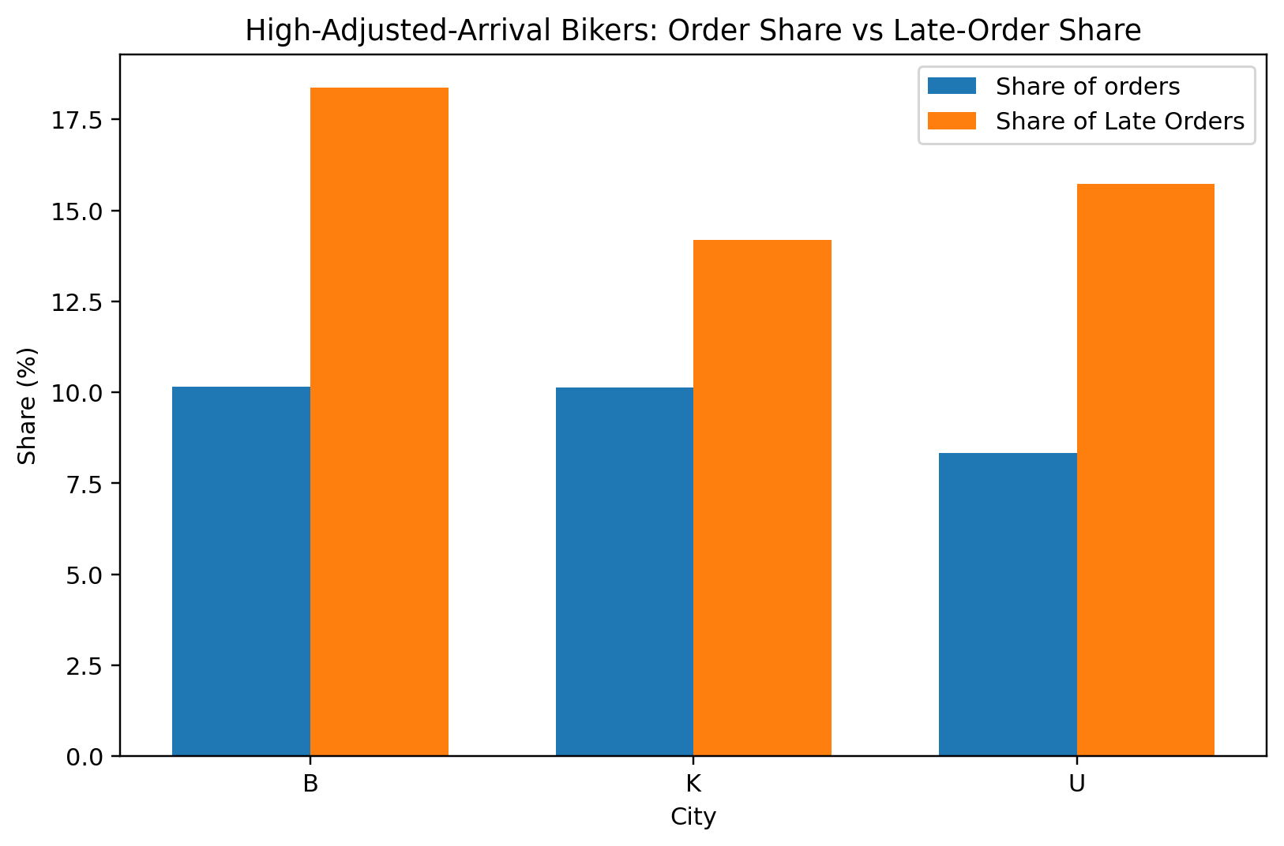
In addition, Adjusted Arrival Performance was substantially persistent between the August-September period and October. The Spearman correlation of Biker Performance between these periods was approximately 0.76 in City B, 0.62 in City K, and 0.68 in City U.
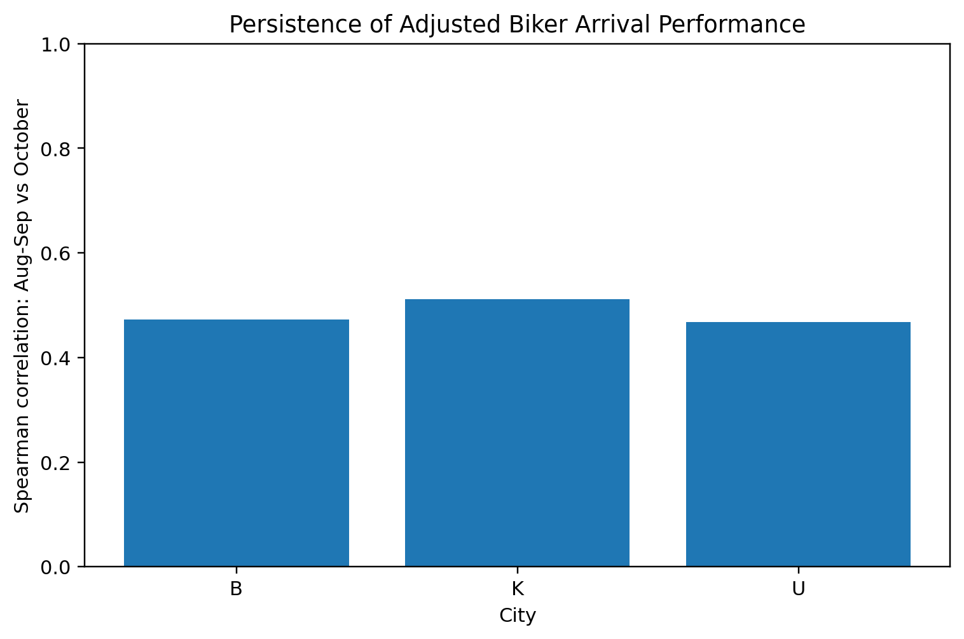
This result indicates that part of the variation in Post-Acceptance Performance is not simply Random Noise, and some bikers have persistently higher Arrival Times.
2.13. Biker Pool Structure
In most Districts, bikers move across several areas, but three Districts in City K showed a different structure:
• K-4176: Exclusive Biker Share ≈ 95.9%
• K-4532: ≈ 97.7%
• K-4732: ≈ 93.9%
In contrast:
• K-1480: ≈ 11.6%
• U-1400: ≈ 14.1%
• B-3740: ≈ 45.6%
These three Districts in City K therefore have highly isolated Biker Pools.
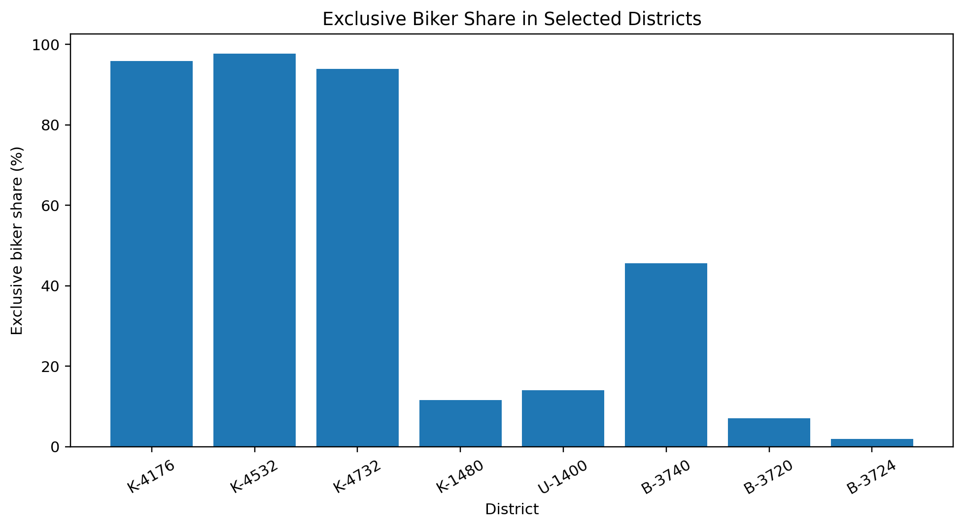
This does not by itself prove the existence of a formal Dedicated Fleet, but it shows that the Mobility Structure of these areas differs from that of other Districts.
The same three Districts are also Arrival-driven in terms of their BATR components:
• K-4176: Δ Median Arrival ≈ +16 min
• K-4532: ≈ +18 min
• K-4732: ≈ +17 min
At the same time, Δ Acceptance Median is approximately zero.
However, the Context Gaps for these areas are not negative:
• K-4176: +0.25 pp
• K-4532: +12.26 pp
• K-4732: +7.65 pp
These areas therefore have a distinct Arrival Process, but they are not the main cause of weak performance in City K.
2.14. Vendor-Level Analysis
To determine whether District-level problems are driven by a few specific Vendors or by a broader area-level issue, Vendors with at least 30 Sequential orders were examined.
In the Core K Districts, Late Orders were not unusually concentrated among a few specific Vendors. For example:
District | Top 5 Vendors - Share of Orders | Top 5 Vendors - Share of Late Orders
K-1480 | 19.2% | 19.9%
K-1512 | 31.3% | 33.4%
K-1528 | 40.5% | 43.7%
K-1484 | 53.2% | 49.0%

Across all four areas, the share of Late Orders generated by the Top Vendors was approximately proportional to their share of Order Volume. The K Core problem is therefore not limited to a few Restaurants and is more consistent with an Area-level Process Problem.
In U-1400, all eight high-volume Vendors had Acceptance P90 above the City U Baseline, while only 25% had Arrival P90 above the Baseline. The Acceptance Problem in U-1400 is therefore also broad-based.
In B-3740, 96.97% of high-volume Vendors had Arrival P90 above the City B Baseline. In K-4176, K-4532, and K-4732, the corresponding values were 97.2%, 91.4%, and 100%, respectively.
These results show that the Arrival Problems in these areas are also not limited to one or two specific Restaurants.
2.15. Multivariate and Non-Linear Analysis
To assess whether the observed relationships were only the result of univariate comparisons or whether combinations of variables and Non-linearity also mattered, an independent Predictive Model was built using information available before the Outcome occurred.
Acceptance Time, Arrival Time, BATR, and Offer Badge were excluded from this model to avoid Leakage.
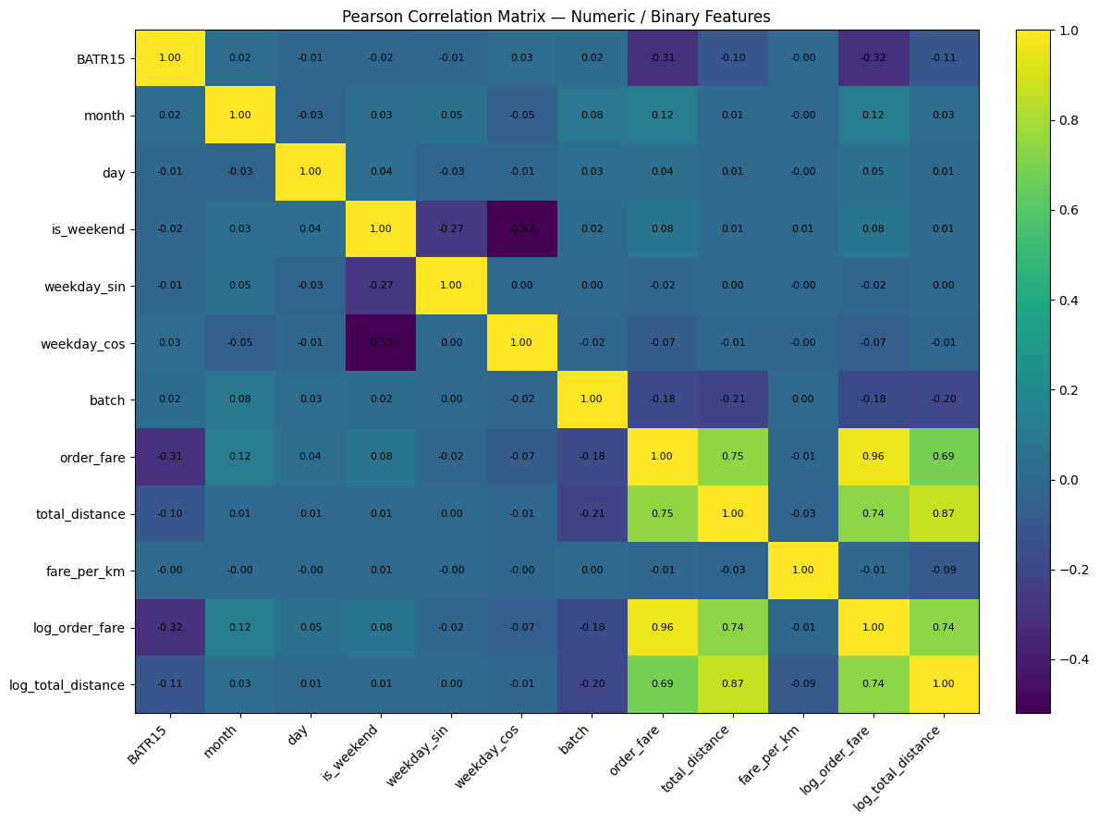
The Weighted Soft-Voting Model achieved approximately the following results on the Test Set:
• Accuracy: 83.8%
• Balanced Accuracy: 77.8%
• Late-order Recall: 66.9%
• Late-order F1: 65.0%
• ROC-AUC: 0.858
• PR-AUC: 0.670
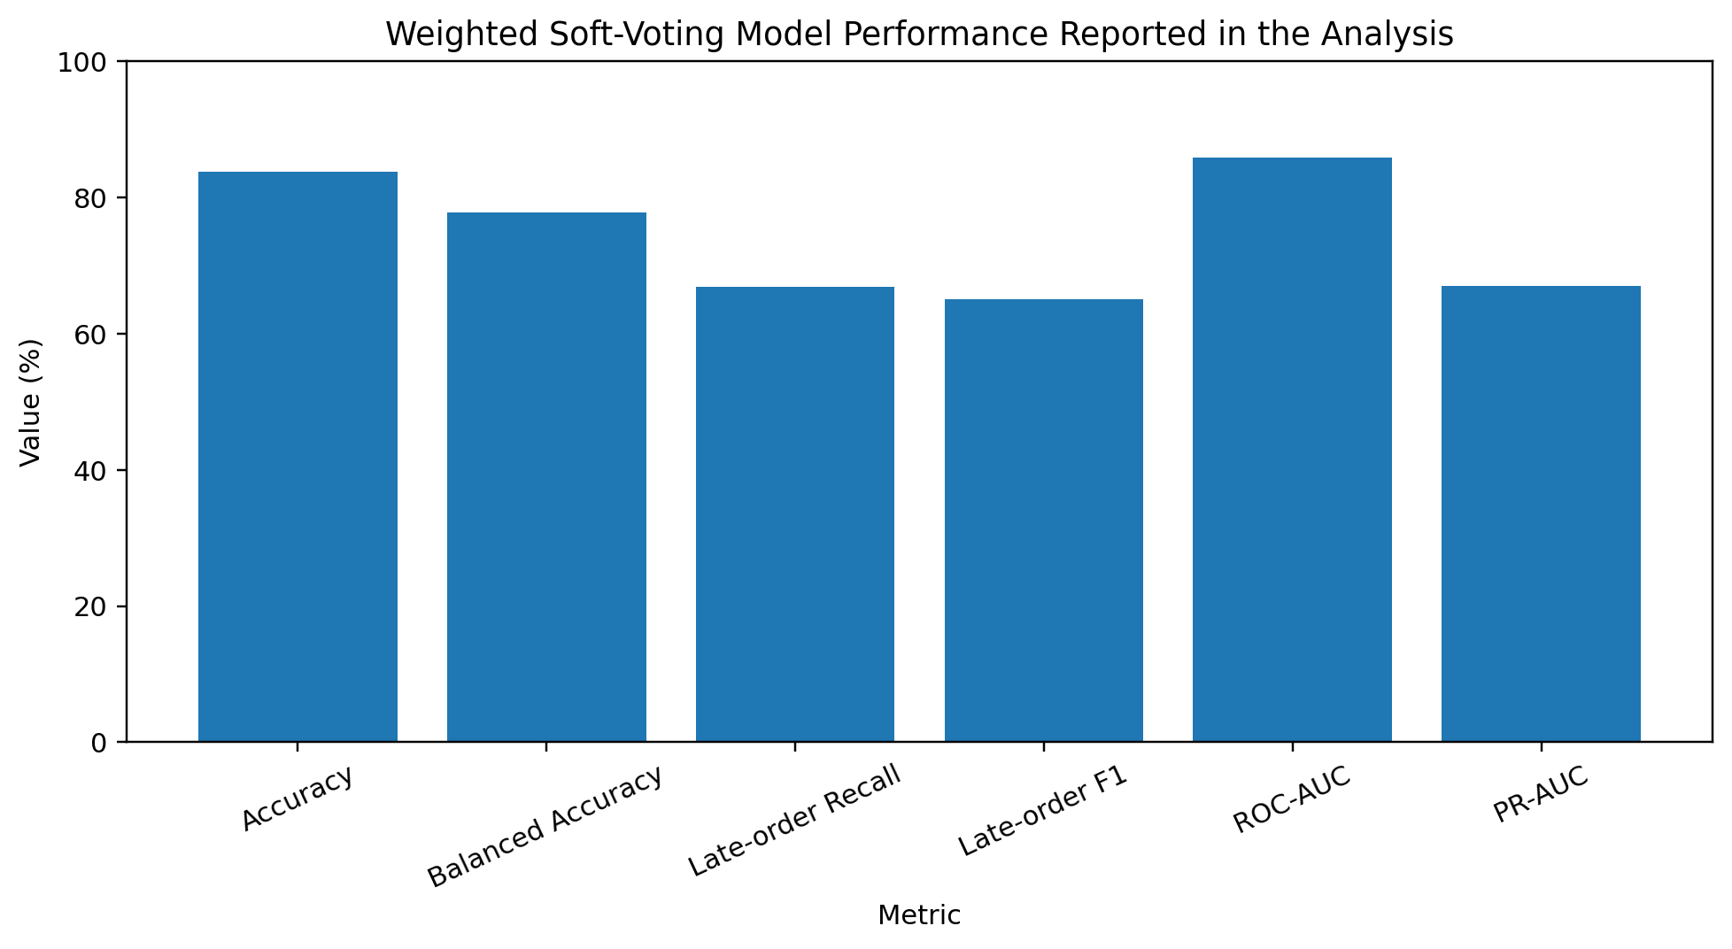
In the Ensemble Feature Importance, the most important variables included order_fare, fare_per_km, city_district, district, Weekday, and Month.
SHAP Analysis also identified Fare, Fare per Distance, Calendar Variables, and Geography among the most important Predictive Features.
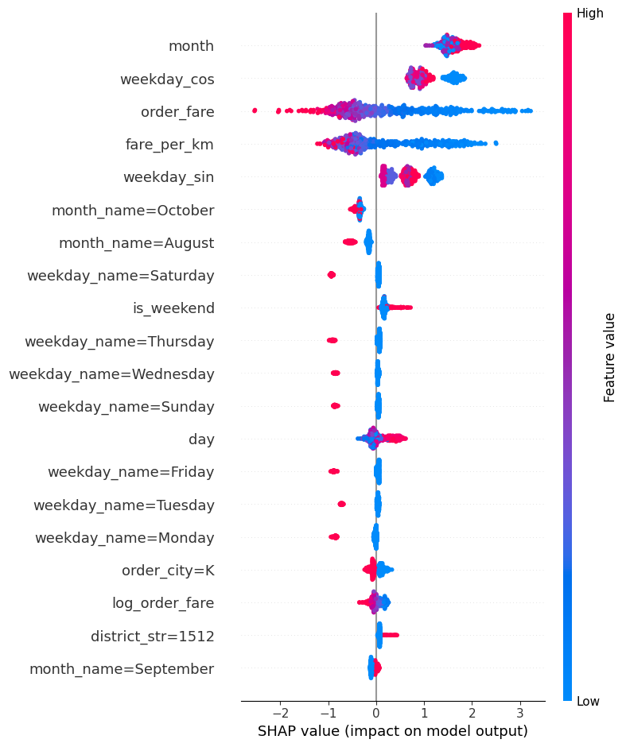
This result shows that BATR reflects a combination of Geography, Time, and Order Characteristics, and its relationship with the variables is not purely Linear.
However, Predictive Importance does not imply Causal Importance. Machine Learning was therefore used for Screening and Pattern identification, not for determining Root Causes.
2.16. Direct Answers to the Questions Defined in Task 1
To connect the analytical results directly to the questions defined at the beginning of the report, each question is summarized below.
Question 1 - In which Cities and Districts is BATR15 lower, and where are the most Late Orders generated?
City K, with BATR15 of 72.43%, is the weakest City and generates 63.6% of all Late Orders. The most important District by Impact is K-1480, with 8,018 Late Orders. In terms of Local Underperformance, U-1400 has the most severe issue, with a Context Gap of approximately -11.17 pp. Both Severity and Volume should therefore be considered when selecting Interventions.
Question 2 - Are the problems temporary or persistent?
City K performs poorly in all three months, and its Core Districts show similar patterns across different Peak Hours. The K problem is therefore persistent and cannot be explained by a short-term Incident.
City U is more dynamic. Performance improved in September and deteriorated in October, with most of the new deterioration driven by Arrival Time. City B improved over the period.
Question 3 - In weak areas, is the problem Acceptance or Arrival?
• K-1480, K-1512, K-1528, and K-1484: mainly Acceptance
• U-1400: mainly Acceptance
• B-3740: mainly Arrival
• K-4176, K-4532, and K-4732: mainly Arrival
• U-1428: Mixed
• City U deterioration from September to October: mainly Arrival
There is therefore no single Root Cause for the entire network.
Question 4 - What temporal patterns exist?
Lunch Peak and Dinner Peak are the weakest periods. Hours 12-13 and 18-21 carry the greatest Risk. Thursday and Friday are slightly weaker than other days, but the Day-of-Week effect is smaller than the effects of City, District, and Hour. City K remained weak throughout all three months, confirming that its main issue is persistent.
Question 5 - How are the dimensions related to BATR?
The relationships are both Linear and Non-linear, and Raw Comparisons can be misleading for some variables. Fare has a strong Predictive relationship with BATR, but a substantial part of this relationship is shared with Badge, Geography, and Distance. Distance has a weaker direct relationship.
The initial Fare-per-Distance Hypothesis is not supported. Batch is a clear example of Selection Bias: Raw Data makes it appear slightly better, while Matching and Regression reverse the direction of the relationship. Delayed Badge also has a very strong relationship with BATR, but it is primarily an Indicator of the Acceptance Process rather than a Root Cause.
Question 6 - Do specific bikers have weak performance?
Acceptance Time cannot be directly attributed to the final biker, so the Biker Analysis focused on Arrival Time. Bikers with high Adjusted Arrival Time account for approximately 10% to 11% of Orders but 15% to 17% of Late Orders, and their performance is also relatively persistent over time. Biker-level Investigation therefore has operational value, but definitive Attribution requires GPS, Route, and Traffic Data.
Question 7 - Are District problems driven by a few specific Vendors?
The evidence indicates that the problem is broad-based in the K Core, U-1400, B-3740, and the K Arrival-heavy Districts. In the K Core, the share of Late Orders generated by large Vendors is approximately proportional to their share of Order Volume. In U-1400, all high-volume Vendors have Acceptance P90 above the City Baseline. In B-3740, approximately 97% of high-volume Vendors have Arrival P90 above the City Baseline. An Intervention focused only on a few specific Restaurants would therefore probably not address the main problem.

Task 3 – Root Cause Analysis
In the RCA, I distinguish between Evidence-supported Process Problems and Operational Root-Cause Hypotheses. The data can identify whether Delay is generated mainly in Acceptance or Arrival, but in some cases additional information is required to determine the exact operational cause.
3.1. Core K Districts – Acceptance-Side Bottleneck
The most important Process Problem is observed in K-1480, K-1512, K-1528, and, to a lesser extent, K-1484. These four Districts generate approximately 71.4% of all Late Orders in City K. All of them continue to show Local Underperformance after Context Adjustment.
Among Late Orders, the increase in Acceptance Median is approximately 11 to 13 minutes, while the increase in Arrival Median is approximately 3 to 5 minutes. In K-1480, K-1512, and K-1528, High Load causes a 10 to 19 Percentage Point decline in BATR15, with the deterioration occurring mainly in Acceptance.
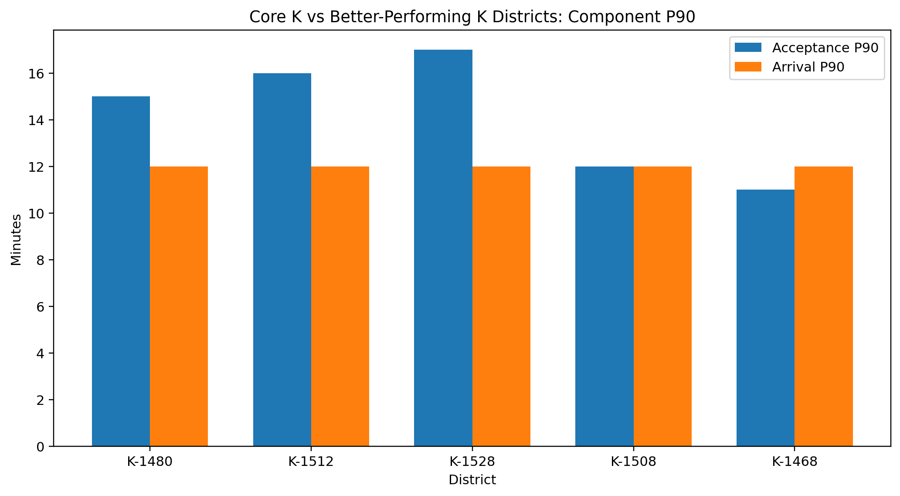
Delayed Offer Rate is also approximately 27% to 30% in these Districts, substantially above the City K average. Vendor Analysis shows that the problem is not limited to a few specific Restaurants.
The evidence is therefore consistent with the Hypothesis that, during Peak Load, Effective Supply or Assignment Capacity is insufficient relative to Demand, causing Orders to remain unaccepted for longer periods.
This mechanism may be caused by an insufficient number of Available Bikers, poor Supply Positioning, Offer Ignore/Rejection, Assignment Inefficiency, or multiple Re-offers.
Data Required to Confirm
• Active / Available Biker Count
• Biker Location at Offer Time
• Offer Attempts per Order
• Offer Recipients
• Reject / Ignore Events
• Offer Acceptance Rate
• Compensation / Incentive
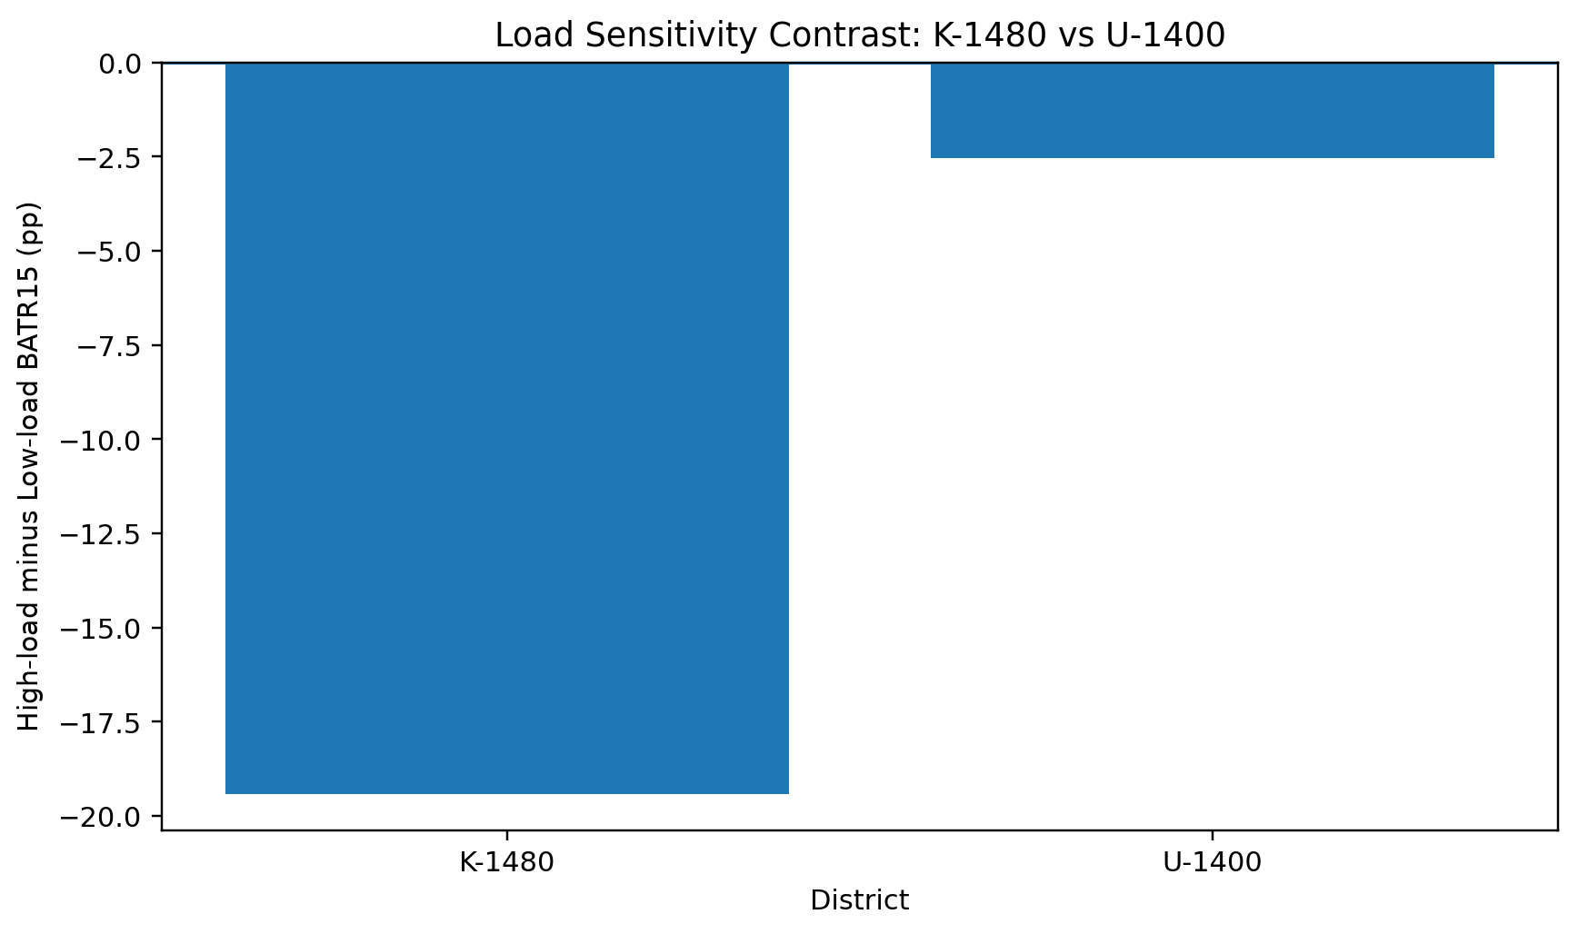
3.2. U-1400 – Broad Local Acceptance Problem
Evidence
U-1400 has a BATR15 of approximately 69.8% and a Context Gap of approximately -11.17 pp, the most severe Gap among Districts with meaningful Volume.
For Late Orders, Δ Median Acceptance is approximately +15 minutes, while Δ Median Arrival is approximately +3 minutes. All high-volume Vendors have Acceptance P90 above the City U Baseline, and Delayed Offer Rate is approximately 24.2%.
However, High Load deteriorates performance by only approximately 2.5 Percentage Points, and Adjusted Acceptance remains almost unchanged. U-1400 therefore has a genuine Acceptance Problem, but there is not enough evidence to attribute it to Order Volume or Supply Pressure.
The main Hypotheses are:
• Offers are sent to bikers who are poorly positioned in terms of Location.
• Reject / Ignore Rate is high.
• The number of Re-offers is high.
• Offer Attractiveness is insufficient.
• Available Bikers are located in an unsuitable part of the District.
Data Required
• Complete Offer Funnel
• Recipient Biker
• Reject / Ignore Decision
• Number of Re-offers
• Offered Incentive
• Biker GPS at Offer
• Biker-to-Restaurant Distance
3.3. B-3740 – Post-Acceptance Arrival Problem
BATR15 in this District is approximately 85.2%, but given its Context it would be expected to be approximately 91.8%. The Context Gap is -6.15 pp.
For Late Orders, Δ Median Acceptance is approximately +6 minutes and Δ Median Arrival approximately +12 minutes. Approximately 66% of total Late Minutes are associated with the Arrival Stage.
Approximately 97% of high-volume Vendors have Arrival P90 above the City B Baseline. The Exclusive Biker Share in this District is also approximately 45.6%, which is higher than in typical Districts in City B.
This pattern is consistent with a Positioning or Mobility problem after Acceptance. The main possibilities are:
• Long Biker-to-Restaurant distance at the time of Acceptance
• Traffic
• Route inefficiency
• Previous Delivery Endpoint
• Concurrent Orders
Data Required
• Biker GPS at Acceptance
• Biker-to-Restaurant Distance
• ETA at Acceptance
• Actual Travel Time
• Traffic Data
• Previous Order Drop-off
• Concurrent Assignments
Area | Metric | High-volume vendors | Share above city baseline (%)
U-1400 | Acceptance P90 | 8 | 100.0
B-3740 | Arrival P90 | 33 | 96.97
K-4176 | Arrival P90 | 36 | 97.22
K-4532 | Arrival P90 | 35 | 91.43
K-4732 | Arrival P90 | 12 | 100.0

Area | Dominant stage | Observed pattern | Evidence | Operational hypothesis
K-1480 | Acceptance | High-load deterioration | 8,018 late orders; -3.40 pp Context Gap | Supply / assignment capacity
K-1512 | Acceptance | Persistent local bottleneck | 3,367 late orders; -5.30 pp Context Gap | Assignment / offer process
K-1528 | Acceptance | Persistent local bottleneck | 2,392 late orders; -6.82 pp Context Gap | Assignment / offer process
U-1400 | Acceptance | Broad local problem | 1,256 late orders; -11.17 pp Context Gap | Offer / positioning / attractiveness
B-3740 | Arrival | Broad local problem | 674 late orders; -6.15 pp Context Gap | Positioning / mobility
K-4176/4532/4732 | Arrival | Distinct process, not main K root cause | Highly isolated biker pools | Positioning / network structure

3.4 Additional RCA Findings
Delayed Offer Badge
The Delayed Badge should not be treated as a Root Cause. Its threshold-like Assignment around an Acceptance Delay of approximately 11 minutes and its very strong relationship with Acceptance indicate that the Badge is mainly a Process State Indicator.
Delayed Offer Rate is therefore highly useful for Monitoring, but the Intervention should target the cause of its increase rather than the Badge itself.
Batch
Raw Data presents a positive picture of Batch, but Matching and Regression show that after comparing similar orders, Batch is associated with weaker BATR15. This association is approximately 8 to 9 Percentage Points in Cities K and U.
However, Batch is not Randomly Assigned. It should therefore still be treated as a Potential Operational Risk Factor rather than an Evidence-supported Root Cause.
Fare and Distance
Fare, Distance, and Fare per Distance contain Predictive information, but the data does not support a simple mechanism in which low Fare leads to low motivation and therefore high BATR. In particular, Fare per Distance does not show such a pattern.
A general increase in Fare is therefore not defensible as a BATR solution based on the current data. An Offer-level Experiment would be a more appropriate way to test true Price Sensitivity.
Biker Performance
Adjusted Arrival Performance persists over time for a group of bikers, and this group accounts for more Late Orders than expected based on its volume. This supports creating a Biker-level Review for Arrival Performance, but because GPS and Route Data are unavailable, it should not be used as definitive evidence of poor individual performance.
Special K Districts
K-4176, K-4532, and K-4732 have high Arrival Time and highly isolated Biker Pools, but their Context-adjusted Performance is not weaker than the City. These areas are therefore important for Positioning and Network Design Investigation, but they are not the main Root Cause of low BATR15 in City K.

Task 4 – Operational Action Plan
The purpose of this Action Plan is not only to temporarily reduce BATR, but to select actions that are directly connected to the Problem Patterns observed in the data, can be implemented at the appropriate time, and can have their effects measured in a Controlled manner. In line with the Task structure, each action specifies the Addressed Problem, Expected Impact, Effort, Owner, and Timing.
Four criteria were used for Prioritization. Impact was evaluated based on the number of affected Orders, the number of Late Orders, and the size of the Performance Gap. Effort represents the operational, Product, and Data resources required for implementation. Feasibility indicates how quickly and practically the Action can be implemented with current capabilities. Finally, each Action should first be tested on a limited scale and expanded only if Improvement is observed without undesirable Side Effects.
Action Plan Summary
Priority | Action |  | Target Area | Problem Addressed | Expected Impact | Effort | Feasibility | Primary Owner | Activation / Timing
1 |  | Peak-hour Biker Supply & Repositioning | K-1480 | Acceptance deterioration under High Load | Very High | Medium | Medium-High | City Operations + Biker Supply | 10-20 min during incident / 1-week pilot
2 |  | Earlier Offer-Pool Expansion & Pre-Delay Rescue | K-1512, K-1528 and aging orders | Persistent Acceptance Delay and high Delayed Offer Rate | High | Medium | Medium-High | Dispatch Operations + Product | 5-15 min if configurable / 1-week pilot
3 |  | High-Risk Order Rescue & Targeted Incentive | U-1400 | Acceptance problem not explained by local volume | Medium-High | Low-Medium | High | City Operations + Biker Operations | Immediate targeted use / 1-week pilot
4 |  | ETA-Based Assignment & Biker Pre-positioning | B-3740 | Post-Acceptance Arrival Delay | High locally / Medium network-wide | Medium | Medium-High | Dispatch + City Operations | 10-30 min / 1-week pilot
5 |  | ML-Based Predictive Early-Warning System | Network-wide, initially problem Districts | Detecting high-risk orders before BATR deteriorates | High | Medium-High | Medium | Data/BI + Dispatch + Operations | Shadow test immediately; operational integration 1-2 sprints

4.1. Peak-hour Biker Supply and Repositioning – K-1480
K-1480 is the first candidate for Operational Intervention, not only because of its low BATR15, but because it combines high Impact with clear evidence of Acceptance Pressure.
This District generated more than 8,000 Late Orders, representing approximately one-quarter of all Late Orders in the Dataset. In addition, its BATR15 remains below expected performance after Context Adjustment.
More importantly, the behavior of this District changes sharply as Load increases:
Low-load BATR15: ≈ 79.5%
High-load BATR15: ≈ 60.1%
This represents approximately 19.4 Percentage Points of deterioration. At the same time, Adjusted Acceptance Time increases by approximately 4 minutes, while Arrival Time changes by only around one minute. This pattern indicates that High Load mainly places pressure on the stage before Acceptance.
Comparison with better-performing Districts in City K reinforces the same conclusion. Arrival P90 in K-1480 does not differ greatly from K-1508 and K-1468, but Acceptance P90 and Delayed Offer Rate are higher. The first Intervention should therefore not focus on Restaurant-to-Travel.
During problematic Peak Hours, particularly Dinner Peak, the Supply situation in neighboring areas should be checked. Available or Idle Bikers should be repositioned only from Districts that have spare Capacity themselves.
Repositioning should preferably begin before the Backlog is fully formed. Appropriate triggers for activating the Action are:
• Acceptance P90 > 8 min
or:
• Delayed Offer Rate > 5% together with an increase in Order Load
Once the Indicators return to an acceptable range, Repositioning should stop to avoid moving more Supply into the area than necessary.
Owner
The City Operations Manager is responsible for the decision and Activation. Biker Supply / Field Operations is responsible for the actual repositioning of bikers. Operations Analyst / BI should monitor Acceptance P90, Delayed Offer Rate, BATR15, and the condition of the source Districts at short intervals.
Timing
During a real Incident, the decision should be made within approximately 5 minutes, and Repositioning should begin to affect performance over the following 10 to 20 minutes. For structural evaluation of the Action, a pilot of approximately one week during recurring Peak Periods is appropriate.
Impact
Very High. Even a limited improvement in K-1480 can reduce a large number of Late Orders across the Network because of its high Volume.
Effort
Medium. It does not require major Development, but Coordination between Operations and Biker Supply is necessary.
Feasibility
Medium-High. The Action is fast and Reversible. The main limitation is the availability of Spare Capacity in neighboring Districts.
How to Test It
The Pilot should be conducted only during defined Windows, and performance should be compared with Comparable Hours without Intervention or with a Control District.
Primary Metrics:
• Acceptance P90
• Delayed Offer Rate
• BATR15
• Late Orders per Hour
Two important Guardrails should also be monitored:
• Biker Cost per Order
• BATR15 in Districts from which bikers were repositioned
The Action is considered appropriate when Acceptance and Delayed Offer Rate improve first, followed by an increase in BATR15, without deterioration in the source Districts.
4.2. Earlier Offer-Pool Expansion and Pre-Delay Rescue
Target: K-1512, K-1528, and Orders approaching Delay
Reason for the Action
K-1512 and K-1528 are similar to K-1480 in terms of their Acceptance Problem, but there is one important difference: their Order Volume is not as unusual as in K-1480.
The 15-minute Load P90 in K-1512 and K-1528 is approximately 4 to 5 Orders and is closer to K-1508. However, Acceptance P90 is approximately 16 minutes in K-1512 and 17 minutes in K-1528, compared with approximately 12 minutes in K-1508.
Arrival P90 does not differ substantially across these Districts, but Delayed Offer Rate is approximately 27% to 30% in K-1512 and K-1528 compared with approximately 14% in K-1508.
The problem in these areas is therefore more consistent with the Effective Acceptance / Assignment Process than with raw Volume.
Instead of allowing an Order to remain for a long time in the initial Candidate Pool, Offer Expansion should be Progressive. During the first few minutes, the Current Dispatch process is maintained. If the Order is not accepted within the expected time, the Candidate Pool is expanded. If the Order reaches the 6-to-8-minute range, its Priority should increase relative to new Orders and the Offer should be sent to more bikers.
For Orders that pass 8 minutes, Pre-Delay Rescue should be activated; the system should not wait for the Delayed Badge or final Failure.
The Policy can be implemented as follows:
• 0-4 min: Current Assignment
• 4-6 min: Wider Candidate Pool
• 6-8 min: Priority + Faster Re-offer
• > 8 min: Rescue Mode and, if needed, use of candidates from neighboring Districts with acceptable ETA
The eight-minute threshold is also consistent with the Acceptance P90 Alert Threshold and activates the Intervention before the Order enters the very high-risk part of the process.
Owner
Dispatch Operations is the primary Owner. If Candidate Pool or Re-offer Timing requires configuration, the Dispatch / Product Team is responsible for changing the Rule. City Operations should also have authority to activate Incident Mode.
Timing
If the Rules are configurable, the Intervention can be activated within approximately 5 to 15 minutes. If a Product Change is required, an Operational / Manual Override should first be used for Incident Mode, followed by permanent Implementation.
Impact
High, because the Action is applied directly to the Stage that represents the main problem in these Districts.
Effort
Medium. It is more complex than Repositioning, but if Dispatch is configurable it does not require heavy Development.
Feasibility
Medium-High. The main dependency is the flexibility of the Dispatch System.
How to Test It
A subset of Eligible Orders should be processed using Current Logic and another subset using Expanded Offer Logic.
Primary Comparison:
• Acceptance Time
• Acceptance P90
• Delayed Offer Rate
• BATR15
A particularly important Guardrail is Arrival P90, because excessive expansion of the Candidate Pool may bring more distant bikers into the Assignment and shift the Delay from Acceptance to Arrival.
The Action is appropriate when Acceptance decreases and BATR15 improves without meaningful deterioration in Arrival.
4.3. High-Risk Order Rescue and Targeted Incentive – U-1400
U-1400 is one of the most severe Local Underperformers in the Dataset. Its BATR15 is approximately 69.8%, and even after Context Adjustment it remains approximately 11.2 Percentage Points below the expected performance of City U.
For Late Orders, Δ Median Acceptance is approximately +15 minutes, compared with Δ Median Arrival of approximately +3 minutes. The problem is therefore clearly Acceptance-heavy.
Unlike K-1480, however, High Load does not provide a good explanation for this problem. BATR15 changes by only approximately 2.5 Percentage Points between Low and High Load. Increasing biker Supply generally is therefore not necessarily the best Action for this District.
The Order Characteristics analysis also showed that long-distance Orders in U-1400 had higher Risk. In the highest Distance Quartile, both BATR15 and Acceptance Performance were noticeably weaker than for short-distance Orders.
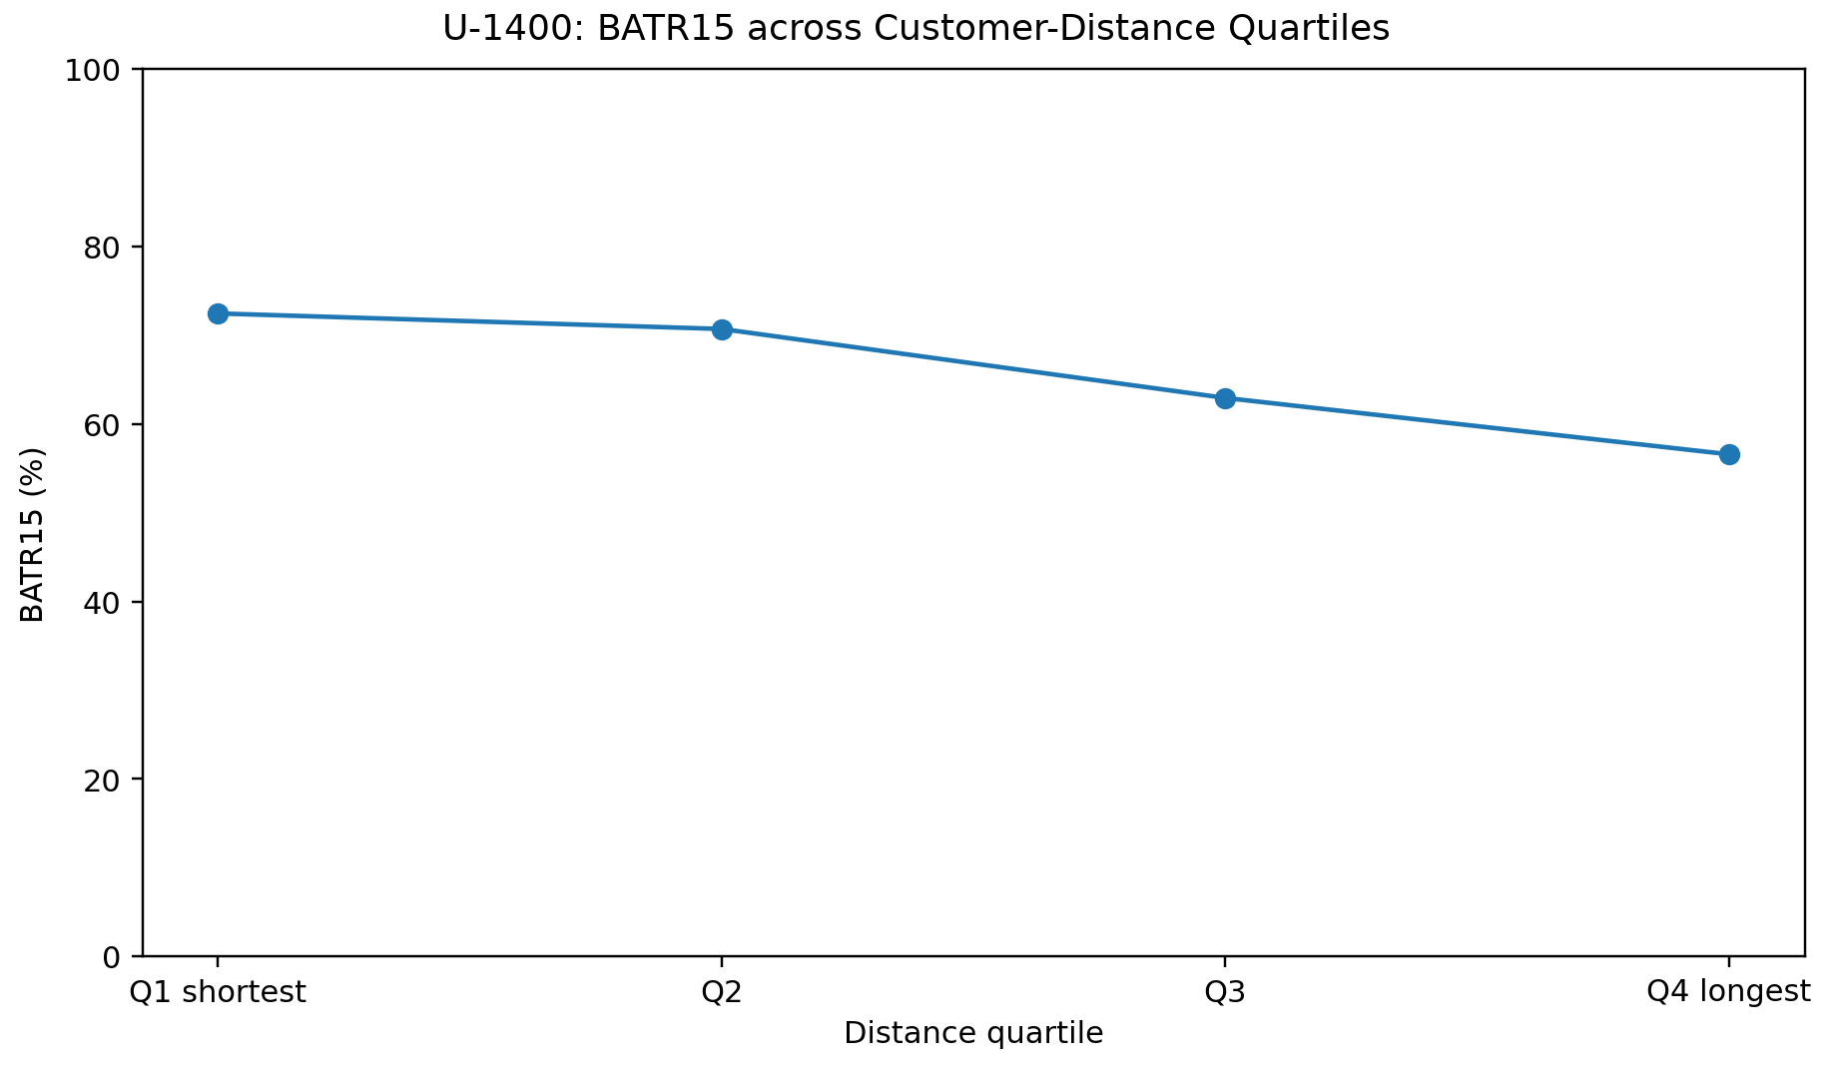
Distance Quartile | Orders | BATR15 (%) | Acceptance Median (min) | Acceptance P90 (min)
Q1 shortest | 914 | 72.43 | 3.0 | 18.0
Q2 | 914 | 70.68 | 3.0 | 20.0
Q3 | 914 | 62.91 | 4.0 | 21.0
Q4 longest | 914 | 56.56 | 8.0 | 23.7

How It Should Work
For U-1400, Targeted Rescue is more appropriate than a general Incentive. Orders that have higher Risk from the beginning, such as long-distance Orders during Problematic Hours, should receive a larger Candidate Pool.
If such an Order remains unaccepted for approximately 4 to 6 minutes, a short-term Micro-Incentive limited to that Order should be activated.
The Action sequence should be:
$$Enhanced Assignment → Fast Re-offer → Targeted Incentive only if still unaccepted$$
The Incentive is therefore the last tool before the Order enters the Delayed State, not the first Intervention applied to all Orders.
Owner
City U Operations is responsible for Activation and the Target Area. Dispatch Operations is responsible for Offer Expansion. Biker Operations / Pricing is responsible for the Rescue Incentive.
Timing
In Incident Mode, this Rule can be activated within approximately 10 to 15 minutes. To evaluate the Economic Effect, a one-week Pilot over Comparable Time Windows is appropriate.
Impact
Medium-High. U-1400 has a large Performance Gap, although its Volume is lower than K-1480.
Effort
Low-Medium. If Incentive and Offer Rules already exist, limited Development is required.
Feasibility
High. Order Distance and District are known from the beginning, making the Intervention fully Targetable.
How to Test It
Eligible High-Risk Orders should be divided into Treatment and Control groups.
Treatment: Expanded Offer + Rescue Incentive after predefined waiting time
Control: Current Process
Primary Metrics:
• Acceptance P90
• Delayed Offer Rate
• BATR15
Financial Evaluation should include Incremental Biker Cost per Order and, more importantly, Incremental Cost per Late Order Avoided.
If BATR Improvement is limited while Cost is high, the Rollout is not appropriate. If a meaningful number of Late Orders can be reduced at limited cost, the Policy can be expanded.
4.4. ETA-Based Assignment and Biker Pre-positioning – B-3740
B-3740 has a different type of problem from K-1480 and U-1400. Its Acceptance does not differ greatly from better-performing Districts in City B, but its Arrival Tail is much longer.
B-3740 Arrival P90 is approximately 16 minutes, compared with approximately 9 minutes in B-3720 and B-3724.
For Late Orders in B-3740, Δ Median Acceptance is approximately +6 minutes, while Δ Median Arrival is approximately +12 minutes, and around 66% of total Late Minutes are associated with the Arrival Stage.
Vendor Analysis also showed that approximately 97% of high-volume Vendors in this District have Arrival P90 above the City B Baseline; the problem is therefore not limited to a few specific Restaurants.
At the same time, the Exclusive Biker Share in B-3740 was noticeably higher than in better-performing Districts in City B. This pattern is more consistent with a Mobility / Positioning Problem.
In Incident Mode, Assignment in B-3740 should become more sensitive to ETA-to-Restaurant. If several Eligible Bikers are available, the candidate with the lower ETA should receive higher Priority.
If the internal Candidate Pool is insufficient, bikers from neighboring Districts can also enter the Pool, but only when their ETA to the Restaurant is lower than that of the existing candidates.
The second action is to Pre-position a number of Available Bikers near Vendor Clusters in B-3740 before Peak periods.
The objective is therefore not simply to provide more bikers, but to ensure that better-positioned and closer bikers are available at the time of Acceptance.
Owner
City B Operations is responsible for the Operational Decision and Pre-positioning. Dispatch/Product is responsible for ETA-based Priority, while Biker Supply is responsible for moving bikers.
Timing
ETA-based Priority can be activated within approximately 10 minutes if it is configurable. Pre-positioning requires approximately 15 to 30 minutes to take effect.
Impact
High at District Level / Medium Network-wide. B-3740 has a genuine and clearly identified problem, but its Volume is lower than the K Core.
Effort
Medium. Repositioning is simpler, but ETA-based Assignment may require Product Support.
Feasibility
Medium-High. If GPS and ETA are already available in Dispatch, Feasibility is high.
How to Test It
For a subset of B-3740 Orders, Treatment should use ETA-prioritized Assignment, while the Control group should continue with Current Logic.
Primary Metric: Arrival P90
Additional metrics are BATR15, Median Arrival, and Late Order Rate. Acceptance P90 should be used as a Guardrail.
If Arrival decreases but Acceptance increases by the same amount, the Policy is not successful because the Delay has only shifted from one Stage to another.
4.5. ML-Based Predictive Early-Warning and Proactive Intervention
The previous four Actions are mainly activated after early signs of a Problem become visible. To allow Operations to intervene before BATR actually deteriorates, the Machine Learning model developed in the analysis can be used as an Early-Warning Layer.
The final model achieved approximately the following results on the Test Set:
• Accuracy: 83.8%
• Balanced Accuracy: 77.8%
• Late-order Recall: 66.9%
• F1: 65.0%
• ROC-AUC: 0.858
• PR-AUC: 0.670
SHAP and Feature Importance also showed that Geography, Fare, Fare per Kilometer, Month, Weekday, Hour, and Peak-period Features provide substantial Predictive information about the probability of BATR15 Failure.
This model should not be interpreted as a Root-Cause Model. Its role is to answer, before Failure occurs: Which orders are currently more likely to exceed BATR = 15 min?
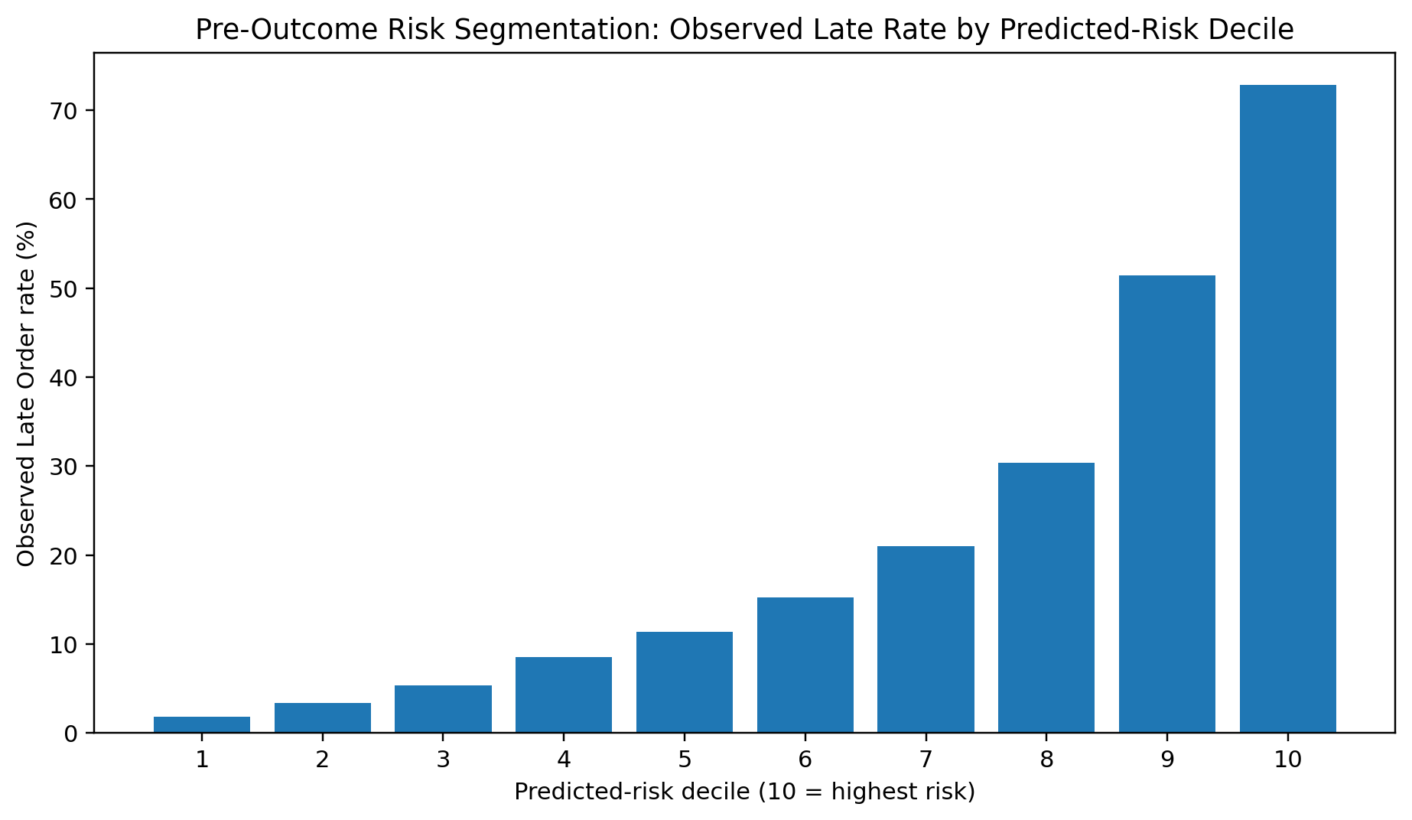
Risk Decile | Orders | Observed Late Rate (%) | Mean Predicted Risk (%)
1 | 6085 | 1.84 | 6.58
2 | 6085 | 3.37 | 11.65
3 | 6085 | 5.39 | 16.6
4 | 6085 | 8.55 | 23.85
5 | 6085 | 11.37 | 34.28
6 | 6084 | 15.27 | 45.24
7 | 6085 | 21.0 | 57.03
8 | 6085 | 30.37 | 69.79
9 | 6085 | 51.41 | 82.4
10 | 6085 | 72.83 | 90.53

When each Order is created, a Predicted Late Risk should be calculated using only information available at that moment. In Production, only variables available before the Outcome occurs should be used, such as City, District, Hour, Weekday, Fare, Distance, Batch, and other Order Characteristics.
Final Acceptance Time, final Arrival Time, BATR, or any variable created after the Delay occurs must not be included in Real-time Prediction.
The model has two applications.
Order-Level Prediction
If an Order is classified as High Risk, it is not necessary to wait for it to age. From the beginning, its Offer Priority can be increased, its Candidate Pool can be expanded, and Re-offers can be sent faster.
The type of Action should depend on the District. For example:
• High Risk + K-1480 → Supply / Repositioning support
• High Risk + K-1512/K-1528 → Earlier Offer Expansion
• High Risk + U-1400 → Targeted Rescue
• High Risk + B-3740 → ETA-based Assignment
This connection between ML and RCA is important. ML identifies which Order is at Risk, while RCA determines which Action is operationally appropriate for it.
District-Level Prediction
Risk Scores for Orders should be aggregated within 5-to-10-minute Windows. If the share of High-Risk Orders in a District increases abnormally, Operations can activate an Intervention before BATR15 deteriorates.
For example, if K-1480 is entering a pattern that the model identifies as High Risk, Biker Repositioning can begin 10 to 20 minutes before the full decline in BATR becomes visible.
The preferred process is:
$$Increasing Predicted Risk → Early Intervention → Lower Acceptance/Arrival Delay → Prevention of BATR Failure$$
rather than:
$$BATR Failure → Detection → Intervention$$
Owner
Data/BI Team is responsible for Model Scoring, Calibration, and Monitoring. Dispatch/Product is responsible for connecting Risk Score to Dispatch Rules. Operations defines the Intervention associated with each Risk Alert and makes the final Activation decision.
Timing
Because the model has already been developed, the first stage can quickly run in Shadow Mode. Predictions are stored without affecting Dispatch to confirm that Real-time Performance remains similar to the Test Set.
After initial Validation, connecting the Risk Score to the Actions can be completed in approximately 1 to 2 sprints.
Impact
High. The main advantage of this Action is reducing Reaction Time and enabling the previous Interventions to be activated before Failure occurs.
Effort
Medium-High. The model itself already exists, but Production Scoring, Dispatch Integration, and Monitoring require Data/Product Work.
Feasibility
Medium. Analytically, the model is ready, but final Feasibility depends on Real-time Data Infrastructure.
How to Test It
The first stage should be a Shadow Test. Risk Scores should be stored for one week without affecting Dispatch. The analysis should verify that the High-Risk Group in new data actually has a higher Late Rate than other Orders and that model Calibration is maintained.
High-Risk Orders should then be divided into Treatment and Control groups. Treatment receives the early Intervention, while Control continues with the Current Process.
At this stage, the primary metric is no longer model Accuracy. The main Business Value metric is Late Orders Prevented by Early Intervention.
This should be evaluated together with BATR15, Acceptance P90 / Arrival P90, and Incremental Cost per Late Order Avoided.
The model has Operational value only if it not only Predicts Failure but also leads to an actual reduction in Late Orders when its Predictions are used.
A Recall of approximately 67% also means that the model should not replace Real-time KPI Monitoring. The best design uses two layers simultaneously:
• Predictive Layer: identifies Risk before it occurs.
• Reactive Layer: rescues Orders that, despite Prediction, have entered Acceptance Delay or Delayed State.
Final Prioritization and Rollout Logic
These Actions should not be applied simultaneously across the entire Network without separating the underlying Mechanisms.
When BATR declines, the first step is to identify which Stage is responsible for the problem.
If the problem is Acceptance-driven and Load-driven, as in K-1480, Supply Repositioning has the highest priority.
If the problem is Acceptance-driven without unusually high Load, as in K-1512 and K-1528, Offer Pool Expansion and Pre-Delay Rescue have higher priority.
If a clear Risk Segment exists, such as long-distance Orders in U-1400, Targeted Rescue and Incentive are more appropriate than a general increase in Supply or Fare.
If the problem is Arrival-driven, as in B-3740, ETA-based Assignment and Positioning should be implemented.
Finally, the ML Model should operate as a higher-level layer above all of these actions to identify which Orders and Districts need Intervention before Failure becomes visible.
Pilot | Treatment | Control | Primary metrics | Guardrails | Evaluation window
K-1480 supply repositioning | Peak windows with repositioning | Comparable peak windows / control district | Acceptance P90; BATR15 | Source-district BATR15; Biker cost/order | 30-60 min incident read; 1 week pilot
K-1512/K-1528 offer expansion | Expanded candidate pool | Current dispatch logic | Acceptance P90; Delayed Offer Rate | Arrival P90 | 30-60 min read; 1 week pilot
U-1400 targeted rescue | Expanded offer + rescue incentive | Current process | Acceptance P90; BATR15 | Incremental cost per Late Order avoided | 1 week
B-3740 ETA assignment | ETA-prioritized assignment | Current assignment | Arrival P90; BATR15 | Acceptance P90 | 30-60 min read; 1 week pilot
ML predictive trigger | High-risk orders receiving early action | High-risk orders under current process | Late Orders prevented | Cost per Late Order avoided; calibration | 1 week shadow + controlled pilot

If only one immediate Action must be selected, Peak-hour Supply/Repositioning in K-1480 is the most appropriate option because the evidence for its mechanism is relatively strong, its Late Order Volume is very high, and the Action can be implemented quickly and is Reversible.
At a structural level, the next most important action is Predictive Early-Warning combined with Area-specific Intervention. This moves the Operations mechanism from Reactive to Preventive and allows Intervention to begin before Backlog fully forms and BATR15 deteriorates.

Task 5 – Operational Scenario
In this scenario, it is 8:00 p.m. and, in one of the main Zones, Order Volume has increased by approximately 30%, Active Bikers have decreased by 15%, BATR P90 has reached 24 minutes, and both Cancellation Rate and Biker Cost per Order are rising. Under these conditions, my priority would not be to complete a full RCA immediately. I would first stabilize the situation and prevent the Backlog from growing further and Cancellation from increasing. A more detailed investigation of the causes would follow after the Incident is under control.
5.1. What I Would Check First
During the first few minutes, I would first make sure that the decline in Performance is real and is not caused by a Dashboard refresh issue or an obvious problem in the data. I would then use Power BI to compare the Zone with the previous 15 to 30 minutes and with the normal conditions for the same hour.
The most important question for me at this stage is whether the deterioration in BATR is driven more by Acceptance Time or Arrival Time. I would therefore review Acceptance P90, Arrival P90, Delayed Offer Rate, BATR15, and BATR P90 alongside Order Volume and Active Bikers.
Given that Demand has increased while Active Supply has decreased, my first Hypothesis would be Capacity Pressure, particularly if Acceptance P90 and Delayed Offer Rate have also increased at the same time. However, if Acceptance remains approximately normal while Arrival P90 increases noticeably, the required Action would be completely different.
5.2. Immediate Actions
If the problem is Acceptance-driven, my first action would be limited Biker Repositioning from neighboring Zones. Using the Dashboard, I would identify which nearby areas still have acceptable BATR and Acceptance performance and are not under pressure, and I would reposition Bikers only from those areas. The performance of the source Zones would be monitored at the same time to make sure that the problem is not simply transferred from one Zone to another.
At the same time, Orders that have remained unaccepted for longer should receive higher Priority. Orders approaching 6 to 8 minutes can receive faster Re-offers or a larger Candidate Pool, while Orders that have passed approximately 8 minutes should enter Rescue Priority. The objective is to intervene before an Order effectively enters a severe Delay state.
I would not activate a general Incentive for the entire Zone at the beginning because Biker Cost per Order is already increasing. If, after approximately 10 to 15 minutes, Repositioning and Rescue Priority have still not improved Acceptance, a short-term Targeted Incentive can be activated only for the same Zone and the same Time Window.
Therefore, my decision sequence would be as follows:
$$Reposition Supply → Prioritize Aging Orders → Expand Assignment if needed → Targeted Incentive if the problem persists$$
If the Backlog continues to increase despite these actions and the abnormal Demand is caused by a controllable Campaign or Promotion, I would also consider a Temporary Reduction as the next option.
If the problem is Arrival-driven, I would not continue increasing Supply broadly. In this case, Assignment should be directed toward Bikers closer to the Restaurant, and if Repositioning is used, Bikers should be moved closer to high-volume Restaurant Clusters. In other words, an Acceptance Problem requires improving Effective Supply and Assignment speed, while an Arrival Problem should focus primarily on Positioning.
5.3. Communication
Because it is 8:00 p.m., I would keep the number of people involved as low as possible. Under normal conditions, in addition to myself, I would coordinate only with the On-duty City Operations / Dispatch Owner to execute Repositioning or Dispatch Priority and, if needed, with the Biker Supply / Engagement Owner for Biker movement or Incentives.
At this stage, I would not see a need to hold a large Meeting with Product, Data, Finance, or other teams. I would Escalate the issue only if there were signs of a System Issue or if an essential Action could not be executed because of a technical limitation.
Communication should also be brief and Action-oriented. It should clearly state what happened, what the likely Bottleneck is, what Action has been taken, and when the result will be reviewed again.
5.4. Monitoring during the Next 60 Minutes
During the next 60 minutes, I would review the Dashboard in windows of approximately 5 to 10 minutes. Not all KPIs have equal importance, and I would expect the effect of the Intervention to appear in a specific sequence.
If the Intervention targets Acceptance, Acceptance P90 and Delayed Offer Rate should improve first. After a short Lag, I would expect BATR P90 to decrease and BATR15 to increase. Cancellation Rate would usually respond slightly later.
Alongside these KPIs, I would also monitor Arrival P90 to make sure that expanding the Candidate Pool has not resulted in Bikers who are too far away being Assigned. Biker Cost per Order and the performance of the Zones from which Supply was moved would also serve as the main Guardrails.
If Acceptance does not improve during the first 10 to 15 minutes, continuing the same Action alone would not be reasonable, and the next Action should be activated. Similarly, if Acceptance improves but Arrival deteriorates, the Dispatch Rule should be adjusted. In practice, the decision process would operate as a Loop:
$$Action → KPI Response → Continue / Adjust / Stop$$
5.5. How I Would Determine Whether the Actions Worked
I would not measure success only through a reduction in BATR. If the objective of the Action is to reduce Acceptance Delay, I would expect Acceptance P90 and Delayed Offer Rate to improve first, followed by a response in BATR and Cancellation.
For a quick decision, I would compare performance during the most recent 10 to 15 minutes with the period before the Intervention. In the short term, the Action would be considered successful if the target Component improves, BATR P90 moves back toward its normal range, BATR15 increases, and Cancellation at least stops increasing, while Cost does not increase to an unacceptable level and neighboring Zones do not deteriorate.
If no clear Improvement is observed after approximately 20 to 30 minutes, I would revisit the initial Diagnosis rather than intensifying the same Action.
Longer-Term Follow-up
After the Incident is under control, I would move to a deeper RCA. If the problem was Acceptance-driven, I would examine data such as Offer Attempts, Reject/Ignore events, Time to First Offer, Available Biker Count, and Re-offers to determine whether the issue was primarily related to Supply or to the Dispatch/Offer Process. If the problem was Arrival-driven, Biker GPS at Acceptance, Biker-to-Restaurant Distance, ETA, and Traffic Data would become more important.
If the same Pattern repeats during similar Peaks, I would no longer treat it as a temporary Incident. Peak-hour Staffing, Biker Positioning, or Dispatch Rules would then need to be corrected structurally.

